West Prairie Free Lutheran Church
Sunday School 9:15 a.m.
Worship Service 10:30 a.m.
Third Sunday of Easter – April 19th, 2026

Prelude – Welcome – Announcements
Call to Worship Psalm 117
Praise the Lord, all nations! Extol him, all peoples! For great is his steadfast love toward us, and the faithfulness of the Lord endures forever. Praise the Lord!
Hymn Day by Day Hymn 568
Praises and Prayer Requests
Confession of Sin
Gracious God, we confess that we have longed too much for the comforts of this world. We have loved the gifts more than the giver. In your mercy, help us to see that all the things we pine for are shadows, but you are substance; that they are quicksands, but you are mountain; that they are shifting, but you are anchor. We plead your forgiveness on the merits of Jesus Christ. Accept his worthiness for our unworthiness, his sinlessness for our transgressions, his fullness for our emptiness, his glory for our shame, his righteousness for our dead works, his death for our life. We pray in Jesus’ name. Amen.
Declaration of Grace
Worship Song Projected
Scripture Readings 1 Peter 1:17-25 Pew Bible 1015 Luke 24:13-35 Pew Bible 885
Confession of Faith Apostles’ Creed Hymnal p. 32
Offering
Hymn There Shall Be Showers of Blessing Hymn 516
Message Don't Be Trippin' Romans 14:13-23 Pew Bible 949
Hymn I Love to Tell the Story Hymn 304
The Lord’s Prayer
Benediction & Doxology Hymn 390

This week at West Prairie (April 19 – April 26)
Today 7:00 p.m. Truth Rising Bible Study
Mon 7:00 p.m. Women’s Evening Monthly Bible Study
Tues 5:30 p.m. Hope Blooms (Spots still available!)
7:00 p.m. Men’s Monthly Bible Study
Wed 5:45 p.m. Confirmation
7:00 p.m. Youth Group
Fri 5:30 p.m. Ladies Evening in Valley City (contact Allie Solseth)
Sat 10:00 a.m. Bridal Shower for Rayna Larsen (RSVP to Heidi)
6:00 p.m. Aspire Event (contact Melissa Lynnes)
Sun 9:15 a.m. Sunday School
10:30 a.m. Worship Service
Congregational Meeting following the service
6:30 p.m. Baccalaureate Service
7:00 p.m. Truth Rising Bible Study (Last one!)

ANNOUNCEMENTS
Directory: Check out the updated directory in the Narthex to make sure all your information is correct by April 26.
Annual Conference Volunteers Needed: The annual conference is going to be held at Concordia College this June 10-13, and they have asked for us to provide VBS/Nursery help on June 11 from 8:00 a.m. – 5:00 p.m. We need two more volunteers identified by April 21st. Talk to Brenna if you are willing!
Sermon Class: Pastor Ryan will give an intro following the men’s Bible study on Tuesday for those interested in the sermon class.
Building Congregational Meeting: Another meeting is scheduled for building project updates! Please join us after church on April 26th to discuss next steps.
Cleaning Week: We are trying something new for spring cleaning spreading it out over a week (April 27-May 2). If you can come throughout the week that would be helpful or else come for the finale on Saturday!
Love Offering: We will be collecting a “Love Offering” to gift to Rayna and Chuck for their upcoming wedding. If you would like to financially contribute- Venmo @Stephanie-Patenaude-1 or give to Stephanie by May 3rd.
Men’s Brunch is back on May 3rd! Everyone is invited to brunch after the service that day served by the men.

VBS: We are doing shirts this year for VBS and to guarantee we have one in your kids’ size- please make sure to register by May 10!

Reader next Sunday Lynn Strand
Ushers next Sunday: Jared and Jennifer Ness
Custodians for April: DuBord and McDonald Families

How to give:
Offering
https://westprairieaflc.com/donate/

Planning Center App found at this QR Code:

Giving Update:
March Giving: $15,323.82
Monthly Budget: $14,208.33
Yearly Giving: $49,214.96
Yearly Budget: $42,624.99

Narthex resources to take home:
West Prairie Visitor Book
Lutheran Ambassador
West Prairie Directory
West Prairie Service Booklet


Happy Birthday To:
21st - Silas Bakken
22nd - Lyle Andvik
24th - Jennifer Ness

Happy Anniversary To:
21st- Michael and Sarah Klockmann

Future Dates:
- Annual Conference (June 10-13)
- Confirmation Sunday (May 17th)
- Baccalaureate (April 26)
- VBS (June 1-4)
- Wilderness Retreat (August 13-16)
- Youth Party (May 20)

Cookbook
We have a West Prairie church cookbook for sale! They should be delivered by Mother’s Day. If you would like to buy one- there is a sign-up in the Narthex. Payments can be by cash, check (JOY), or Venmo @BrennaBerge

Missionary of the Month
Name: Paul and Becky Abel
Serving: Brazil
Prayer Requests: 1) Remaining faithful in this later season of ministry 2) Upcoming couple’s meeting they are holding 3) “Abel” who is dying from a degenerative disease 4) Praise for recent Children’s Camp and after camp Bible Study

April Monthly Bible Studies
Women: April 20th at 7:00 p.m.
Women: April 9th at 10:00 a.m.
Men: April 21st at 7:00 p.m.

Are you new here?
Announcements, prayer requests, serving opportunities get sent out via email and text! We would love to get you in the loop. You can sign up by going to www.wpfl.flocknote.com or by scanning this QR Code:
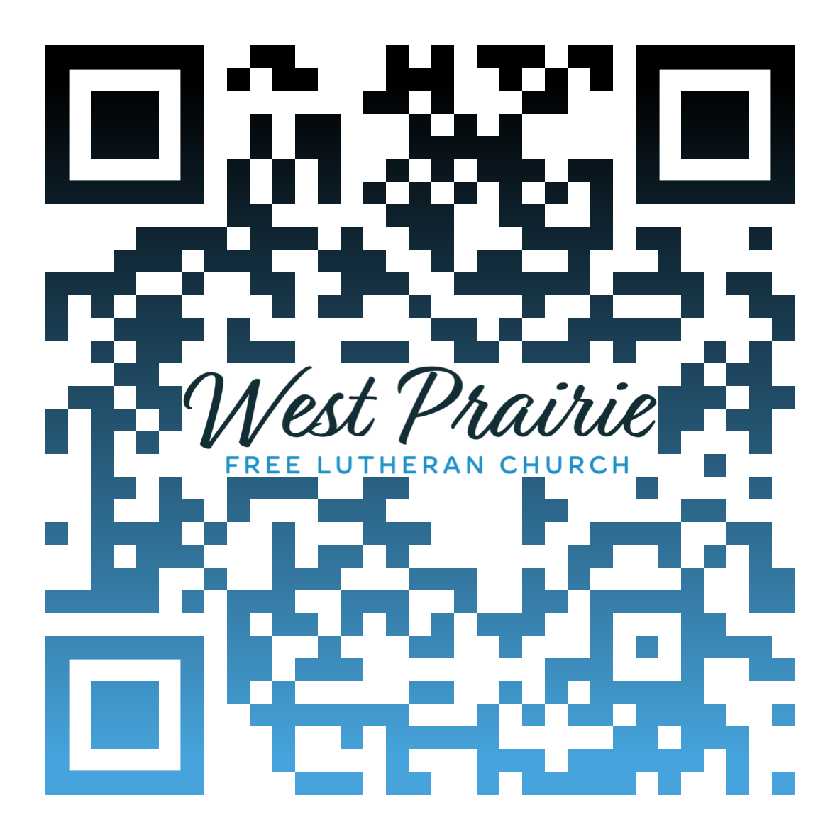
*Have any questions or needs, call Pastor Ryan at 701-429-7101

Follow Me

In John 1:43, we read a simple yet profoundly life-changing invitation from Jesus: “The next day Jesus decided to leave for Galilee. Finding Philip, He said to him, ‘Follow Me.’”
Just two simple words—Follow Me—yet within them lies the heart of the entire Gospel. Jesus does not call us to a religious practice, a set of routine rituals, or a list of personally obtained achievements. He calls us to Him and Him alone. His invitation is personal. Jesus finds Philip and speaks directly to him. Before Philip could serve, preach, or lead, he was first called to follow. This is the point where true discipleship begins. Jesus’ call is not about what we can do for Him, but what He intends to do in and through us. To follow Him means to walk closely with Him, to learn His ways, and to trust His direction even when the path is unclear or unknown.
When Jesus said, “Follow Me,” He was not offering worldly comfort or convenience. Jesus does not promise an easy journey, but He promises His presence. The One who calls us to follow never leaves us alone on the path. Following Jesus means surrendering control. It means trusting Him when the road seems uncertain and obeying even when it costs us something. But in that surrender, we find true freedom. In following Him, we discover who we were always meant to be. As Philip followed, he would soon witness miracles, hear the words of Jesus change lives, but also face challenges and persecution. Yet through it all, Philip discovered something much greater: the joy of knowing the Savior personally.
Today, Jesus continues to make the same call to each of us: “Follow Me.” Not “follow your feelings,” “follow the crowd,” or “follow success,” but “Follow Me.” His call cuts through the noise of this world, challenges our selfish nature, and calls us to something eternal.
So today, pause and hear His voice again: “Follow Me.” Let those words draw you away from distraction and into devotion. When we fix our eyes on Jesus, we find the way, the truth, and the life, and there is no greater calling than to walk where He leads.

Mr. Kirk Rautio
Association Retreat Center Director
Osceola, Wisconsin

AFLC Promotion for April is the ARC

HIDDEN TEXT

West Prairie Free Lutheran Church (AFLC)
Making the Gospel Known
15720 Highway 46 and 18 S. Kindred ND 58051
Pastor Ryan Patenaude 701-429-7101
https://westprairieaflc.com

