West Prairie Free Lutheran Church
Sunday School 9:15 a.m.
Worship Service 10:30 a.m.
Fourth Sunday of Easter– April 26th, 2026

Prelude – Welcome – Announcements
Call to Worship Psalm 95:1-2
Oh come, let us sing to the Lord; let us make a joyful noise to the rock of our salvation! Let us come into his presence with thanksgiving; let us make a joyful noise to him with songs of praise!
Hymn Like a River Glorious Hymn 581
Praises and Prayer Requests
Confession of Sin The Ten Commandments Hymnal p. 23
Declaration of Grace
Worship Song Projected
Scripture Readings Acts 2:42-47 Pew Bible 911 John 10:1-10 Pew Bible 896
Confession of Faith Apostles’ Creed Hymnal p. 32
Offering
Hymn More About Jesus Hymn 615
Special Music High School Ensemble
Message God's Guidance 1 Samuel 23:1-14 Pew Bible 245
Hymn Am I a Soldier of the Cross Hymn 472
The Lord’s Prayer
Benediction & Doxology Hymn 390

This week at West Prairie (April 26 – May 3)
Today Congregational Meeting following the service!
6:30 p.m. Baccalaureate Service
7:00 p.m. Truth Rising Bible Study (Last one!)
Wed 5:45 p.m. Confirmation
7:00 p.m. Youth Group
Sat 8:00 a.m. Cleaning Week Grand Finale
Sun 9:15 a.m. Sunday School
10:30 a.m. Worship Service
Men’s Brunch (Everyone invited!)

ANNOUNCEMENTS
Pastor Lee Hoops turned 80 on April 18th! If you would like to send him a card to wish him a Happy Birthday you can mail it to: 10145 Karston Cove NE, Albertville, MN 55301.
Directory: Last call for any changes to the copy in the narthex today!
Building Congregational Meeting: Stay after the service today to discuss next steps for the building project!
Cleaning Week: We are trying something new for spring cleaning spreading it out over the week (April 27-May 2). Laura has a list of tasks ready for people to come and get checked off throughout the week whenever it works with your schedule or come on Saturday for the grand finale!
Love Offering: We will be collecting a “Love Offering” to gift to Rayna and Chuck for their upcoming wedding. If you would like to financially contribute- Venmo @Stephanie-Patenaude-1 or give to Stephanie by May 3rd.
Men’s Brunch is back on May 3rd! Everyone is invited to brunch after the service that day served by the men. French toast, sausage, bacon, fruit, and juice will be served! Free-will offering will be taken for the Perry Center.
Confirmation: Elsa Wickham, Farrah DuBord, Henry Woodbury, Rachel Strand, and Rylan Ness will all be confirmed on May 17th.

VBS: We are doing shirts this year for VBS and to guarantee we have one in your kids’ size- please make sure to register by May 10!

Reader next Sunday: Cort McDonald
Ushers next Sunday: Murphy Family
Custodians for May: Ron and Stacy Ness

How to give:
Offering
https://westprairieaflc.com/donate/

Planning Center App found at this QR Code:

Giving Update:
March Giving: $15,323.82
Monthly Budget: $14,208.33
Yearly Giving: $49,214.96
Yearly Budget: $42,624.99

Narthex resources to take home:
West Prairie Visitor Book
Lutheran Ambassador
West Prairie Directory
West Prairie Service Booklet

Happy Birthday To:

28th - Sarah Richardson
30th - Emma Strand
1st - Brad Kommer
1st - Weston Woodbury

Future Dates:
- Confirmation Sunday (May 17)
- Last Day of S.S. (May 17)
- Youth Party (May 20)
- Summer Worship Hours (May 24)
- VBS (June 1-4)
- Annual Conference (June 10-13)
- Wilderness Retreat (August 13-16)

Cookbook
We have a West Prairie church cookbook for sale! They should be delivered by Mother’s Day. If you would like to buy one- there is a sign-up in the Narthex. Payments can be by cash, check (JOY), or Venmo @BrennaBerge

Missionary of the Month
Name: Paul and Becky Abel
Serving: Brazil
Prayer Requests: 1) Remaining faithful in this later season of ministry 2) Upcoming couple’s meeting they are holding 3) “Abel” who is dying from a degenerative disease 4) Praise for recent Children’s Camp and after camp Bible Study

May Monthly Bible Studies
Women: May 18th at 7:00 p.m.
Women: May 14th at 10:00 a.m.
Men: May 19th at 7:00 p.m.

Are you new here?
*Announcements, prayer requests, serving opportunities get sent out via email and text! We would love to get you in the loop. You can sign up by going to www.wpfl.flocknote.com or by scanning this QR Code:
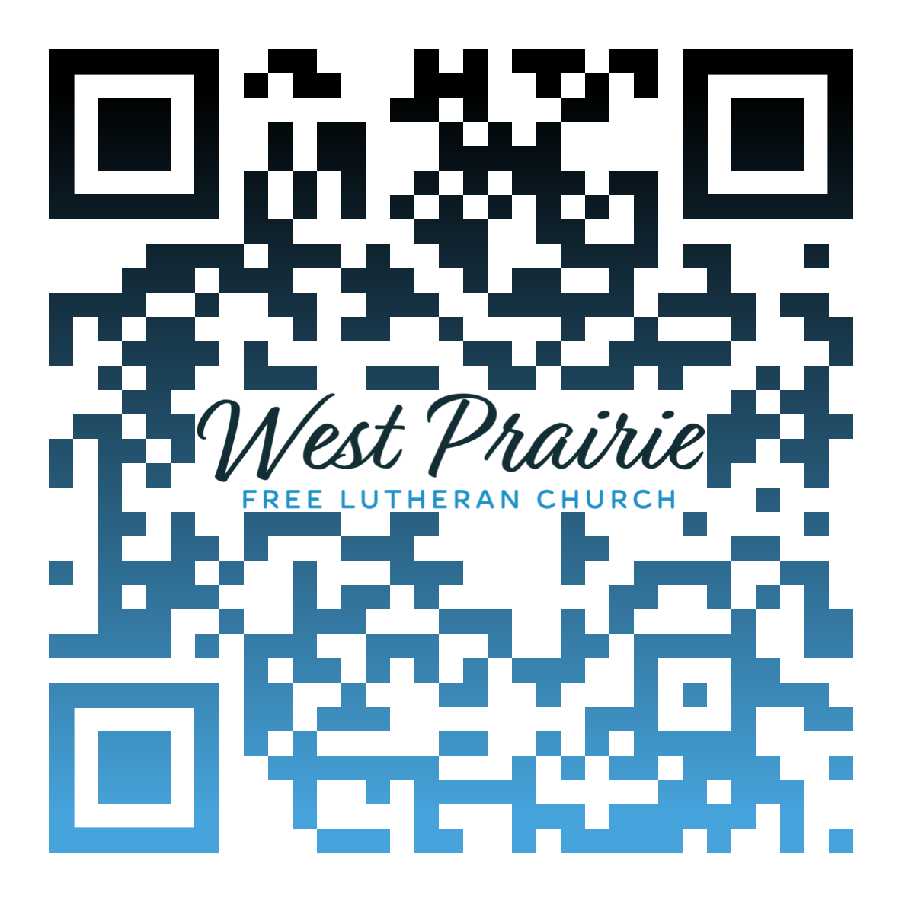
*Have any questions or needs, call Pastor Ryan at 701-429-7101

God the Father Almighty, Creator of Heaven and Earth

The opening words of the Apostles’ Creed declare, “I believe in God the Father Almighty, Creator of heaven and earth.” In this simple yet powerful confession, we affirm not only that God exists, but that He reigns as Father, Almighty, and Creator, three truths that shape our entire understanding of faith and life.
First, He is Father. God reveals Himself in relationship. Through Jesus Christ, we are invited to know the God of the universe as our loving Father. This means the same One who spoke galaxies into being also bends low to hear our prayers. His power is not distant or cold; it is wrapped in compassion, mercy, and love.
Second, He is Almighty. The word “almighty” reminds us that there is nothing too hard for God. He is sovereign over all creation, over time, history, and every circumstance of our lives. Yet His might is not reckless; it is guided by perfect wisdom and love. When we trust in the Almighty, we can rest in the truth that no force in heaven or on earth can thwart His good plans for His people.
Finally, He is Creator of heaven and earth. Every mountain peak, every ocean wave, every star flung across the night sky bears His fingerprint. And through Christ, the Word made flesh, the Father continues His work of new creation in us. The same power that formed the universe now transforms hearts, making all things new through the cross and resurrection of Jesus.
When we declare, “I believe in God the Father Almighty, Creator of heaven and earth,” we are not merely reciting doctrine. We are proclaiming a living relationship with the God who made us, loves us, and sustains us. In Christ, the Creator becomes our Redeemer, and the Almighty becomes our Abba Father.
Let this truth anchor your heart today: The One who holds the stars also holds you, securely, lovingly, and eternally.

Mr. Kirk Rautio
Association Retreat Center Director
Osceola, Wisconsin

AFLC Promotion for April is the ARC

HIDDEN TEXT

West Prairie Free Lutheran Church (AFLC)
Making the Gospel Known
15720 Highway 46 and 18 S. Kindred ND 58051
Pastor Ryan Patenaude 701-429-7101
https://westprairieaflc.com

