West Prairie Free Lutheran Church
Sonrise Service 8:00 a.m.
Worship 10:30 a.m.
Easter Sunday – April 5th, 2026

Prelude – Welcome – Announcements
Call to Worship Psalm 122:1-2,8-9
I was glad when they said to me, “Let us go to the house of the Lord!” Our feet have been standing within your gates, O Jerusalem! For my brothers and companions' sake I will say, “Peace be within you!” For the sake of the house of the Lord our God, I will seek your good.
Hymn Christ the Lord is Risen Today Hymn 104
Praises and Prayer Requests
Special Music Restored Nina Richardson
Confession of Sin
Dear Heavenly Father, we come before you to confess to you that we have grievously sinned and fallen short of your glory. We have not loved you above all things or our neighbors as ourselves. We confess these and other sins to you in order to receive your forgiveness and cleansing. Grant to us your mercy and grace, and help us to live our lives in the way that honors you most. We pray this in the Name of Jesus, Amen.
Declaration of Grace
Worship Song Because He Lives Projected
Scripture Readings Colossians 3:1-4 Pew Bible 984 John 20:1-18 Pew Bible 906
Confession of Faith Nicene Creed Hymnal p. 32
Offering In Christ Alone Choir Ensemble
Hymn Low In The Grave He Lay Hymn 111
Message Not In Vain 1 Corinthians 15:1-11 Pew Bible 961
Special Music He’s Alive Michael Lynnes
Hymn Thine is The Glory Hymn 98
The Lord’s Prayer
Benediction & Doxology Hymn 390

This week at West Prairie (April 5 – April 12)
Mon 7:00 p.m. Council Meeting
Wed 5:45 p.m. Confirmation
7:00 p.m. Youth Group
Thurs 10:00 a.m. Women’s Morning Bible Study
Sun 9:15 a.m. Sunday School
10:30 a.m. Worship Service
7:00 p.m. Truth Rising Bible Study

ANNOUNCEMENTS
Softball: St. Paul’s, our sister church in Fargo, has a men's team playing softball this summer and could use a few more players, so if you are interested, you can contact Aaron Rudebusch (952-913-1076). Games are on Tuesday evenings at 6:30 and 7:30 in north Fargo. Regardless of skill, anyone can join for some cross-congregation fellowship!
Cookbook: We have a church cookbook for sale! They should be delivered by Mother’s Day. If you would like to buy one- there is a sign-up in the Narthex. Payments can be by cash, check (JOY), or Venmo @BrennaBerge
WMF Spring Rally is on April 18th. It is being held in Grand Forks this year. It will be a great day of encouragement focusing on how Jesus is our peace in the chaos. Laura and Debby will be going and would love to carpool!
Hope Blooms: The ladies are headed to Hope Blooms for a fun night of bouquet creations that will be delivered out into the community! April 21st from 5:30-7:00 p.m. will be the night of fun! Sign-up in the Narthex if you are interested- they do require a waiver ahead of time.
Prayer Gathering: There will be a prayer gathering on April 13th at 7:00 p.m. at the church!
Rayna Larsen Shower: The Larsen family is throwing a bridal shower for Rayna on April 25th at 10:00 a.m., and they have invited us to join with them in celebrating the bride-to-be! Please RSVP to Heidi if you plan to attend.

VBS: We are “Kickin’ it Old School” for VBS this year on June 1-4 from 3-5 PM. In a world that is always searching for “the next big thing”, some things never change and can never be improved upon. God, His Word, His Promises, and the Gospel will always remain unchanged. We would love to have your kids join us for a week of fun! You can register now at:

Reader next Sunday: Laura Murphy
Ushers next Sunday: Berge Family
Custodians for April: DuBord and McDonald Families

How to give:
Offering
https://westprairieaflc.com/donate/

Planning Center App found at this QR Code:

Narthex resources to take home:
West Prairie Visitor Book
Lutheran Ambassador
West Prairie Directory
West Prairie Service Booklet

Happy Birthday To:

6th - Tyler Klockmann
6th - Lucas Mauch
7th - Azariah Berge
9th - Conne Andvik

Happy Anniversary To:
7th- Gene and Sue Klockmann

Future Dates:
- Annual Conference (June 10-13)
- Confirmation Sunday (May 17th)
- Baccaulerate (April 26)
- VBS (June 1-4)
- Wilderness Retreat (August 13-16)

Missionary of the Month
Name: Paul and Becky Abel
Serving: Brazil
Prayer Requests: 1) Remaining faithful in this later season of ministry 2) Upcoming couple’s meeting they are holding 3) “Abel” who is dying from a degenerative disease 4) Praise for recent Children’s Camp and after camp Bible Study

April Monthly Bible Studies
Women’s: April 20th at 7:00 p.m.
Women’s: April 9th at 10:00 a.m.
Men’s: April 21st at 7:00 p.m.

Are you new here?
*Announcements, prayer requests, serving opportunities get sent out via email and text! We would love to get you in the loop. You can sign up by going to www.wpfl.flocknote.com or by scanning this QR Code:
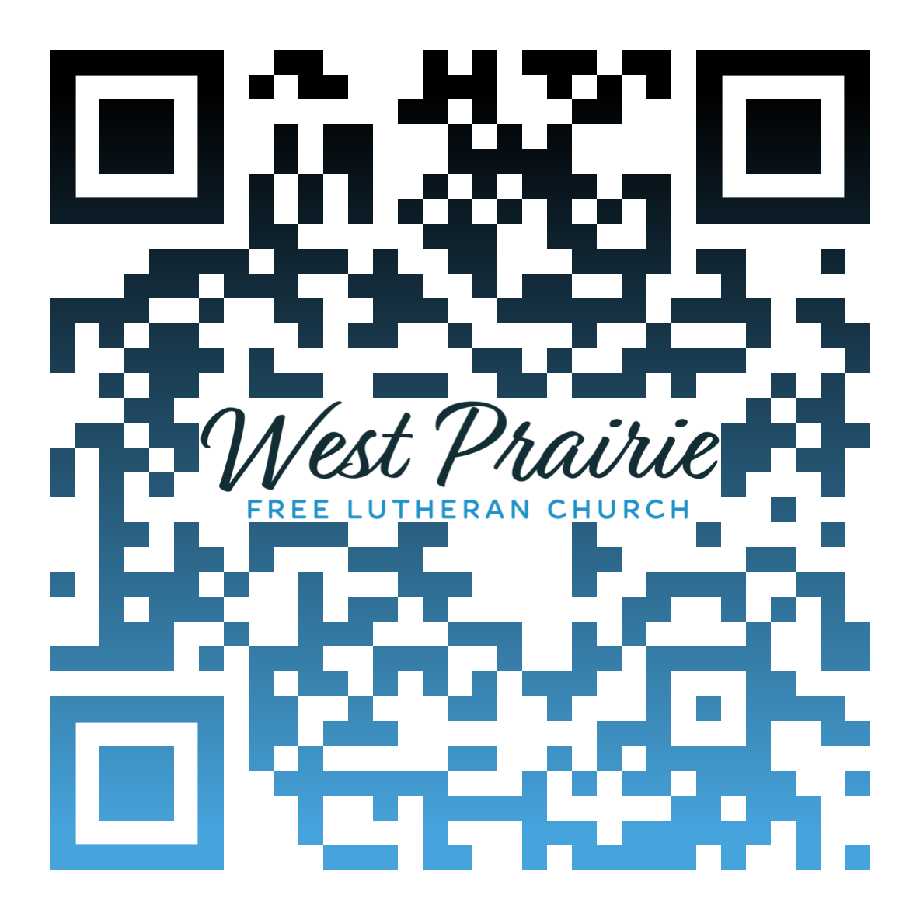
*Have any questions or needs, call Pastor Ryan at 701-429-7101

Jesus All Glorious

Text and Tune: Virgil E. Boe, arr. Oscar R. Overby
Ambassador Hymnal #113

Jesus all glorious, Christ all victorious,
Risen in triumph o’er death and the grave!
Homage we bring Thee,
Praises we sing Thee,
Lord over all, ever mighty to save.

Jesus all glorious, Savior victorious,
Shedding for sinners Thy blood in the strife:
Now there is streaming
Grace all redeeming
Forth from Thy cross with forgiveness and life.

Jesus all glorious, Master victorious,
Thee will we follow, Thy mandates obey:
Bring every nation
Words of salvation,
Trusting Thy promise, “I’m with you always.”

Jesus all glorious, King all victorious,
Reign in Thy power on earth and in Heav’n!
Kingdoms terrestrial,
Honors celestial
Unto our Lord and His Christ shall be giv’n!

AFLC Promotion for April is the ARC

HIDDEN TEXT

West Prairie Free Lutheran Church (AFLC)
Making the Gospel Known
15720 Highway 46 and 18 S. Kindred ND 58051
Pastor Ryan Patenaude 701-429-7101
https://westprairieaflc.com

