West Prairie Free Lutheran Church
Sunday School 9:15 a.m.
Worship Service 10:30 a.m.
Sixth Sunday of Easter– May 10th, 2026

Prelude – Welcome – Announcements
Call to Worship Psalm 117
Praise the Lord, all nations! Extol him, all peoples! For great is his steadfast love toward us, and the faithfulness of the Lord endures forever. Praise the Lord!
Hymn Tis So Sweet To Trust In Jesus Hymn 582
Praises and Prayer Requests
Confession of Sin
Lord Jesus, I have sinned times without number, and been guilty of pride and unbelief, and of neglect to seek you in my daily life. My sins and shortcomings present me with a list of accusations, but I thank you that they will not stand against me, for all have been laid on Christ. Deliver me from every evil habit, every interest of former sins, everything that dims the brightness of your grace in me, everything that prevents me taking delight in you. Amen.
Declaration of Grace
Worship Song Projected
Scripture Readings 1 Peter 3:13-22 Pew Bible 1016 John 14:15-21 Pew Bible 901
Confession of Faith Apostles’ Creed Hymnal p. 32
Offering
Hymn Praise Him! Praise Him! Hymn 539
Message In the Lord's Hands 1 Samuel 24:1-22 Pew Bible 246
Hymn Blessed Assurance Hymn 511
The Lord’s Prayer
Benediction & Doxology Hymn 390

This week at West Prairie (May 10 – May 17)
Wed 5:45 p.m. Confirmation
7:00 p.m. Youth Group
Thurs 10:00 a.m. Women’s Bible Study
Sun 9:15 a.m. Sunday School
10:30 a.m. Worship Service (Confirmation and Teacher Appr.)

ANNOUNCEMENTS
Directory: Updated directories are in the Narthex for you to take home!
Cookbooks: Your name and the number of books you ordered are labeled in the Narthex. There are extra books for you to get more if you would like. Payments can be made via cash or check to West Prairie Building Fund or on the Planning Center App indicated for the Building Fund.
Confirmation: Elsa Wickham, Farrah DuBord, Henry Woodbury, Rachel Strand, and Rylan Ness will all be confirmed on May 17th.
Youth Group Party! Year-end youth group party will be on Wednesday, May 20th at 6:00 p.m. at the Patenaude home. Dinner, pickleball, fire, s’mores. All youth grades 6th and up are welcome!
Lost and Found items were collected during cleaning week and placed in the addition. Please collect any items that belong to you before we donate after next Sunday!
Summer Schedule: Next week is the last week of Sunday school for the season. May 24th will start the summer service schedule with a 9:30 a.m. worship service.
Annual Conference: We need a couple more volunteers for the Annual Conference VBS/nursery on June 11th from 8-5. Anyone interested?
VBS: We are doing shirts this year for VBS and to guarantee we have one in your kids’ size- please make sure to register today!


Wilderness Retreat: The FOURTH annual wilderness retreat registration is open! I dare say it is one of the best weekends of the year. Lots of information about the event can be found at this QR code:


Reader next Sunday: Brenna Berge
Ushers next Sunday: Holt Family
Custodians for May: Ron and Stacy Ness

How to give:
Offering
https://westprairieaflc.com/donate/

Planning Center App found at this QR Code:

Giving Update:
April Giving: $13,040.05
Monthly Budget: $14,208.33
Yearly Giving: $62,255.01
Yearly Budget: $56,833.32

Narthex resources to take home:
West Prairie Visitor Book
Lutheran Ambassador
West Prairie Directory
West Prairie Service Booklet

Happy Birthday To:

TODAY - Jacob Guzik
TODAY - Adam Larsen
11th - Andrew Berge
11th - Nick Kjera
15th - Laura Wickham
15th - Carl Woodbury
16th - Claire Sannes

Future Dates:
- Confirmation Sunday (May 17)
- Last Day of S.S. (May 17)
- Youth Party (May 20)
- Summer Worship Hours (May 24)
- VBS (June 1-4)
- Annual Conference (June 10-13)
- Wilderness Retreat (August 13-16)

Cookbook
We have a West Prairie church cookbook for sale! If you would like to buy one- there is a sign-up in the Narthex. Payments can be made via cash or check to West Prairie Building Fund or on the Planning Center App indicated for the Building Fund.

Missionary of the Month
Name: Zachariah & Carey Ritland
Serving: Paraguay
Prayer Requests: 1) Praise for their new son, Jericho’s birth! 2) Endurance as they continue to learn Spanish 3) Praise for 8 baptisms in their church the past month and that they would continue to grow in faith and devotion to the Lord 4) Paperwork to get their Paraguayan ID cards

May Monthly Bible Studies
Women: May 18th at 7:00 p.m.
Women: May 14th at 10:00 a.m.
Men: May 19th at 7:00 p.m.

Are you new here?
*Announcements, prayer requests, serving opportunities get sent out via email and text! We would love to get you in the loop. You can sign up by going to www.wpfl.flocknote.com or by scanning this QR Code:
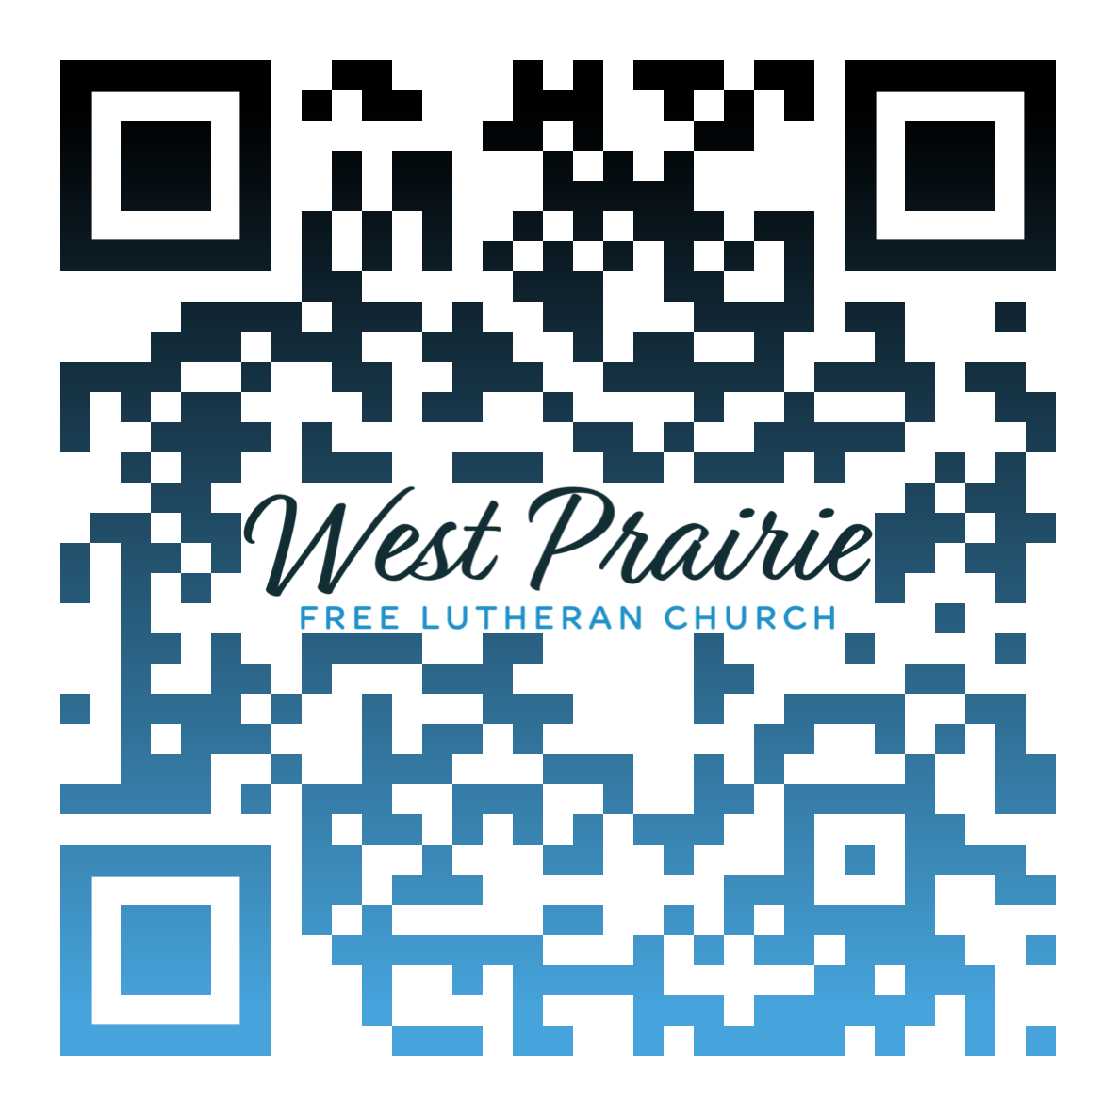
*Have any questions or needs, call Pastor Ryan at 701-429-7101

Mothers are a blessing, aren’t they? Over the past year, I’ve been blessed to see my wife, Maggie, gracefully take on the vocation of motherhood as we welcomed our first child into the world. It has given me a newfound appreciation for the work that mothers do as I’ve witnessed her continually giving of herself to love and care for our daughter. As I consider Maggie, as well as my own mother and grandmothers, I can’t help but think about their legacy as the love they have for their children trickles down through the generations.
In 2 Timothy 1:5, Paul points Timothy back to a faithful legacy that has blessed him: “I am reminded of your sincere faith, a faith that dwelt first in your grandmother Lois and your mother Eunice and now, I am sure, dwells in you as well.” The witness of a faithful mother is a powerful thing. Our mothers are some of the most influential people in our lives, as they teach us through their words and actions in our most formative years and show us what it looks like to love someone unconditionally.
If you’re like me, you can relate to Paul’s words to Timothy here. I’ve been blessed by generations of mothers who have faithfully taught the truths of Scripture to their children, earnestly prayed over them, and lived out the love of Christ as they have served and cared for their children. In Matthew 25:40, Jesus tells us, “Truly I say to you, as you did it to one of the least of these my brothers, you did it to me.” When a mother changes her baby’s diapers, she serves the Lord. When she comforts her crying child in the middle of the night, she serves the Lord. When she helps her son move into his college dorm, she serves the Lord.
Think of the ways that your own mother, grandmothers, and faithful women of the Kingdom have embraced you with the love of Christ, how they have exemplified faithfulness, patience, and endurance, and have served as the very hands of our Lord in caring for us and providing for our needs. Take time today to thank the Lord for the blessing of mothers and the lasting legacy they have. And thank your mother for the ways that she has loved and blessed you.

Mr. Kyle Erickson
Good Shepherd Free Lutheran
Cokato, Minnesota

AFLC Promotion for May is Youth Ministries

HIDDEN TEXT

West Prairie Free Lutheran Church (AFLC)
Making the Gospel Known
15720 Highway 46 and 18 S. Kindred ND 58051
Pastor Ryan Patenaude 701-429-7101
https://westprairieaflc.com

