West Prairie Free Lutheran Church
Sunday School 9:15 a.m.
Worship Service 10:30 a.m.
Seventh Sunday of Easter– May 17th, 2026

Prelude – Welcome – Announcements
Call to Worship Psalm 95:1-3
Oh come, let us sing to the Lord; let us make a joyful noise to the rock of our salvation! Let us come into his presence with thanksgiving; let us make a joyful noise to him with songs of praise! For the Lord is a great God, and a great King above all gods.
Hymn I Know Whom I Have Believed Hymn 525
Praises and Prayer Requests
Confession of Sin Psalm 51:1-7 Pew Bible 474
Declaration of Grace
Teacher Appreciation
Worship Song Projected
Scripture Readings 1 Peter 4:12-19 Pew Bible 1016 John 17:1-11 Pew Bible 903
Confession of Faith Apostles’ Creed Hymnal p. 32
Offering
Confirmation Testimonies
Rite of Confirmation
Hymn I Will Sing The Wondrous Story Hymn 536
Message A Foolish Husband 1 Samuel 25:1-13 Pew Bible 247
Hymn My Hope is Built In Nothing Less Hymn 507
The Lord’s Prayer
Benediction & Doxology Hymn 390

This week at West Prairie (May 17 – May 24)
Mon 7:00 p.m. Women’s Bible Study
Tues 7:00 p.m. Men’s Bible Study
Wed 6:00 p.m. Youth Group Party at Patenaude Home
Sun 9:30 a.m. Worship Service (new summer hours begins!)

ANNOUNCEMENTS
Next Sunday: There is no Sunday school next week, and the service time changes to 9:30 a.m.
Youth Group Party! Year-end youth group party will be on Wednesday, May 20th at 6:00 p.m. at the Patenaude home. Dinner, pickleball, fire, s’mores. All youth grades 6th and up are welcome!
Lost and Found items were collected during cleaning week and placed in the addition. Anything left after today will be donated.
VBS: We are less than a month out from Kickin’ It Old School VBS. We will have a snack station every day at VBS, and we are looking for some food donations to make that possible! There is a sign-up in the Narthex for food items. We would need them all brought to church by May 31 or June 1. Also if you would like to help decorate for VBS- lots of balloons to blow up this year- please come to church on May 31 at 2:30 p.m. to help!
Annual Conference: Registration for annual conference price increases after May 31st. The registration can be found at the QR code on the next page. The conference theme is “Sure Hope” based on Philippians 1:6. Here is the layout:
Wednesday, June 10- WMF Day + 7:00 p.m. Conference Opening
Thursday, June 11 through Saturday June 13 – Conference all day
Wilderness Retreat: The FOURTH annual wilderness retreat registration is open! Lots of information at the QR on the tear-off.
Softball: St. Paul’s, our sister church in Fargo, has a men's team playing softball this summer and could use a few more players, so if you are interested, you can contact Aaron Rudebusch (952-913-1076). Games are on Tuesday evenings at 6:30 and 7:30 in north Fargo. Regardless of skill, anyone can join for some cross-congregation fellowship!
Women’s Walking: All the ladies are invited to join for a rise and shine walking time on Tuesday mornings this summer at 6:00 a.m. starting on June 2nd. We will meet at the Kindred Elementary Parking Lot.
Congratulation Confirmands Elsa Wickham, Farrah DuBord, Henry Woodbury, Rachel Strand, and Rylan Ness.
Congratulation Graduate Ashley Haas!

Reader next Sunday: Solomon Patenaude
Ushers next Sunday: Michael and Sarah Klockmann
Custodians for May: Ron and Stacy Ness

How to give:
Offering
https://westprairieaflc.com/donate/

Planning Center App found at this QR Code:

Giving Update:
April Giving: $13,040.05
Monthly Budget: $14,208.33
Yearly Giving: $62,255.01
Yearly Budget: $56,833.32

Narthex resources to take home:
West Prairie Visitor Book
Lutheran Ambassador
West Prairie Directory
West Prairie Service Booklet

Happy Birthday To:

18th - Megan Woodbury
21st - Keegan Murphy
22nd - Tucker Vangsness
23rd - Gus Gutridge


Future Dates:
- VBS (June 1-4)

- Annual Conf. (June 10-13)


- Wilderness Retreat (August 13-16)


Cookbook
We have a West Prairie church cookbook for sale! If you would like to buy one- there is a sign-up in the Narthex. Payments can be made via cash or check to West Prairie Building Fund or on the Planning Center App indicated for the Building Fund.

Missionary of the Month
Name: Zachariah & Carey Ritland
Serving: Paraguay
Prayer Requests: 1) Praise for their new son, Jericho’s birth! 2) Endurance as they continue to learn Spanish 3) Praise for 8 baptisms in their church the past month and that they would continue to grow in faith and devotion to the Lord 4) Paperwork to get their Paraguayan ID cards

May Monthly Bible Studies
Women: May 18th at 7:00 p.m.
Women: May 14th at 10:00 a.m.
Men: May 19th at 7:00 p.m.

Are you new here?
*Announcements, prayer requests, serving opportunities get sent out via email and text! We would love to get you in the loop. You can sign up by going to www.wpfl.flocknote.com or by scanning this QR Code:
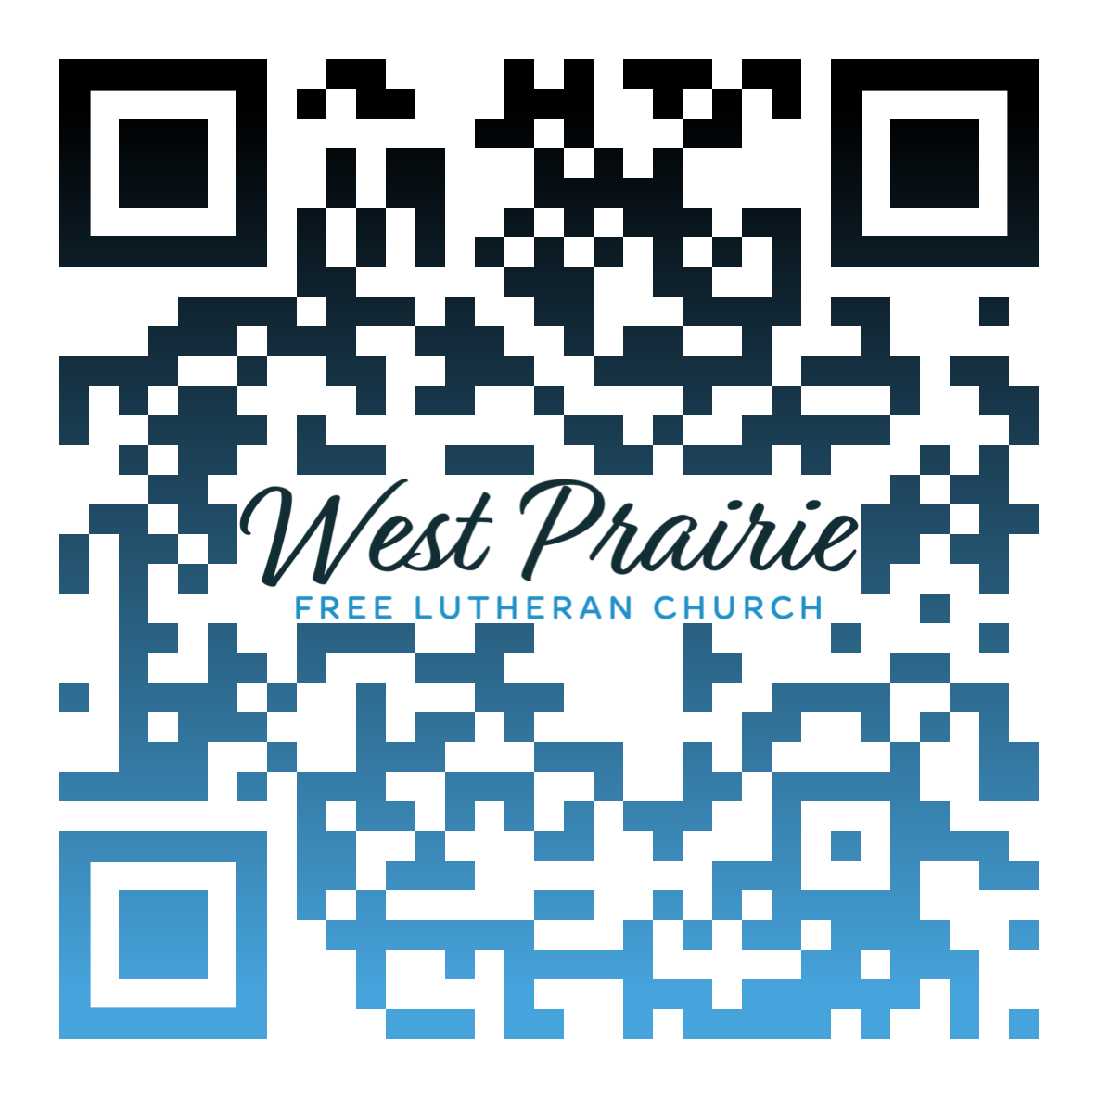
*Have any questions or needs, call Pastor Ryan at 701-429-7101

Psalm 136 serves as a liturgy of praise to God for His ongoing provision for the nation of Israel. The first half of each verse praises God for His character, intervention, and provision, while the second half of each verse is a master class on repetition. While the psalm declares the truth and points us to see God’s faithfulness, the second half of each verse runs the risk of causing you to zone out or skim the rest of the psalm.
26 separate times, we are reminded that God’s steadfast love endures forever. If you’re reading this responsively in a worship service, it’s easy to lose focus because of the repetition. Could it be that our spiritual adversary desires nothing more than for us to forget, overlook, or take for granted the fact that God’s faithfulness and steadfast love endures? I think that’s more than likely.
Bible Interpretation 101: be on the lookout for repetition. This is a literary tool that adds emphasis to what is being said. Some examples of this include the vision in Isaiah 6 as heavenly creatures declare God to be “Holy, Holy, Holy.” We see Jesus using repetition as He teaches the disciples: “Truly, truly I say to you . . .” (John 3:3, 5:24, and 8:34 as examples).
The repetition in Psalm 136 is meant to be more than just a gentle, ongoing reminder to the audience of God’s faithfulness. It’s meant to be a declaration of spiritual heritage—a verbal pillar that grounds the audience on a fundamental truth: that based on His nature alone, God is worthy to receive all praise and glory due Him. This is the message of the elders in Revelation 4 as they affirm the praise given to God for creating what He pleased (4:11). This is the point Jesus makes as He enters Jerusalem, declaring that the rocks will cry out in worship. Psalm 136 serves as an opportunity for us to replace monotony and apathy with joy and thanksgiving as we remind ourselves that God is truly faithful and His love endures.

Pr. Dan Hurner
AFLC Youth Ministries Networking Coordinator
Dalton, Minnesota

AFLC Promotion for May is Youth Ministries

HIDDEN TEXT

West Prairie Free Lutheran Church (AFLC)
Making the Gospel Known
15720 Highway 46 and 18 S. Kindred ND 58051
Pastor Ryan Patenaude 701-429-7101
https://westprairieaflc.com

