West Prairie Free Lutheran Church
Worship Service 9:30 a.m.
Day of Pentecost – May 24th, 2026

Prelude – Welcome – Announcements
Call to Worship Psalm 95:6-7
Oh come, let us worship and bow down; let us kneel before the Lord, our Maker! For he is our God, and we are the people of his pasture, and the sheep of his hand. Today, if you hear his voice,
Hymn Open My Eyes, That I May See Hymn 124
Praises and Prayer Requests
Confession of Sin
Have mercy on me, O God, according to your steadfast love; according to your abundant mercy blot out my transgressions. Wash me thoroughly from my iniquity, and cleanse me from my sin! For I know my transgressions, and my sin is ever before me. Against you, you only, have I sinned and done what is evil in your sight, so that you may be justified in your words and blameless in your judgment.
Declaration of Grace
Worship Song Projected
Scripture Readings Acts 2:1-21 Pew Bible 909 John 7:37-39 Pew Bible 893
Confession of Faith Apostles’ Creed Hymnal p. 32
Offering
Hymn Children of the Heavenly Father Hymn 560
Message Guest Speaker
Hymn Face to Face With Christ My Savior Hymn 623
The Lord’s Prayer
Benediction & Doxology Hymn 390

This week at West Prairie (May 24 – May 31)
Sun 9:30 a.m. Worship Service
2:30 p.m. VBS Decorating for anyone interested!

ANNOUNCEMENTS
VBS: We are only a couple weeks out from VBS! Just a reminder- programming will run 3:00-5:00 p.m. June 1-4. There will be a program at 5:00 p.m. on June 4 and a potluck meal following at 5:30 p.m. There is a snack station during the week that we are taking donations for on a sign-up in the Narthex.

Annual Conference: Registration for annual conference price increases after May 31st. The registration can be found at the QR code on the next page. The conference theme is “Sure Hope” based on Philippians 1:6. Here is the layout:
Wednesday, June 10- WMF Day + 7:00 p.m. Conference Opening
Thursday, June 11 through Saturday June 13 – Conference all day

Memorial Day: The Kindred American Legion Post will be at the West Prairie Cemetery at 1:25 p.m.

Wilderness Retreat: The FOURTH annual wilderness retreat registration is open! Lots of information at the QR on the tear-off.

Softball: St. Paul’s, our sister church in Fargo, has a men's team playing softball this summer and could use a few more players, so if you are interested, you can contact Aaron Rudebusch (952-913-1076). Games are on Tuesday evenings at 6:30 and 7:30 in north Fargo. Regardless of skill, anyone can join for some cross-congregation fellowship!

Women’s Walking: All the ladies are invited to join for a rise and shine walking time on Tuesday mornings this summer at 6:00 a.m. starting on June 2nd. We will meet at the Kindred Elementary Parking Lot.

Reader next Sunday: Ron Ness
Ushers next Sunday: Dennis and Tammy Jones
Custodians for May: Ron and Stacy Ness

How to give:
Offering
https://westprairieaflc.com/donate/

Planning Center App found at this QR Code:

Giving Update:
April Giving: $13,040.05
Monthly Budget: $14,208.33
Yearly Giving: $62,255.01
Yearly Budget: $56,833.32

Narthex resources to take home:
West Prairie Visitor Book
Lutheran Ambassador
West Prairie Directory
West Prairie Service Booklet

Happy Birthday To:

24th - Thorvald (TJ) Jostad
27th - Isaac Klockmann
29th - Larry Solseth

Happy Anniversary To:
26th – Nick and Rachel Kjera


Future Dates:
- VBS (June 1-4)

- Annual Conf. (June 10-13)


- Wilderness Retreat (August 13-16)


Cookbook
We have a West Prairie church cookbook for sale! They are $25 each. If you would like to buy one- there is a sign-up in the Narthex. Payments can be made via cash or check to West Prairie Building Fund or on the Planning Center App indicated for the Building Fund.

Missionary of the Month
Name: Zachariah & Carey Ritland
Serving: Paraguay
Prayer Requests: 1) Praise for their new son, Jericho’s birth! 2) Endurance as they continue to learn Spanish 3) Praise for 8 baptisms in their church the past month and that they would continue to grow in faith and devotion to the Lord 4) Paperwork to get their Paraguayan ID cards

June Monthly Bible Studies
Women: June 15th at 7:00 p.m.
Women: June 11th at 10:00 a.m.
Men: June 16th at 7:00 p.m.

Are you new here?
*Announcements, prayer requests, serving opportunities get sent out via email and text! We would love to get you in the loop. You can sign up by going to www.wpfl.flocknote.com or by scanning this QR Code:
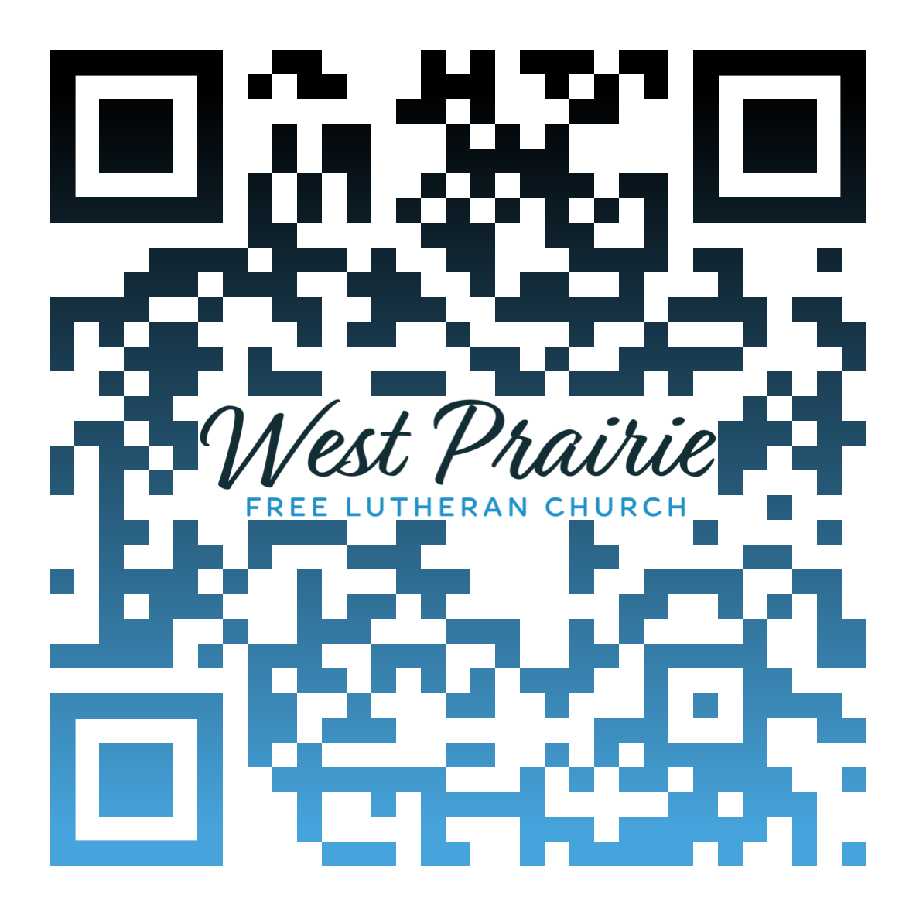
*Have any questions or needs, call Pastor Ryan at 701-429-7101

As congregations, we have unique opportunities to instill certain values and characteristics in our youth as they grow up in our midst. While there are many worthwhile traits to pass along, a quick observation of the world around us suggests that strength and courage should be top priorities. Verses like Joshua 1:9 also speak to the importance of this notion. While it may be tempting to simply refer to this verse and exhort our students and fellow congregants to be strong and courageous as they follow Jesus, it isn’t enough to simply share this exhortation on its own. If we do so, we may be communicating that all one has to do to live a life pleasing to God is to try harder and “man up.” While on the surface, this may look like good advice, it will lead to despair and discouragement as all will eventually recognize that they are not strong or courageous enough to complete the task they have been called to.
Instead of falling into this temptation, we look to the context of this passage where we see that, even in its original form, the exhortation was never for people to simply find the courage or strength within themselves. Instead, this courage and strength was to be rooted in the reality of God’s presence. Rather than saying, “be strong” or “have courage,” our first task is to make sure we are clearly teaching who the Lord is and then reminding everyone that He is truly with us wherever we go. That changes the emphasis from us finding our strength and courage within ourselves to finding strength and courage in Him who is strong enough to create and sustain all that exists through His word and will.
Yes, we live in a time in history where both the church and the world are in desperate need of believers who are living courageously with strength. However, it will not be the strength and courage of man that will challenge the darkness and change hearts. Instead, it will be the faithful presence and love of ordinary people being transformed by the real presence of Jesus Christ in their everyday lives, allowing His strength and courage to be expressed through them. Don’t fall into the trap that you need to become something extra; instead, remember that Jesus already has provided all that you need in Himself and that He is with you wherever you may go.

Mr. Jordan Langness
AFLC Youth Ministry Training Coordinator
Ishpeming, Michigan

AFLC Promotion for May is Youth Ministries

HIDDEN TEXT

West Prairie Free Lutheran Church (AFLC)
Making the Gospel Known
15720 Highway 46 and 18 S. Kindred ND 58051
Pastor Ryan Patenaude 701-429-7101
https://westprairieaflc.com

