West Prairie Free Lutheran Church
Sunday School 9:15 a.m.
Worship Service 10:30 a.m.
Fifth Sunday of Easter– May 3rd, 2026

Prelude – Welcome – Announcements
Call to Worship Psalm 100
Make a joyful noise to the Lord, all the earth! Serve the Lord with gladness! Come into his presence with singing! Know that the Lord, he is God! It is he who made us, and we are his; we are his people, and the sheep of his pasture. Enter his gates with thanksgiving, and his courts with praise! Give thanks to him; bless his name! For the Lord is good; his steadfast love endures forever, and his faithfulness to all generations.
Hymn This is My Father’s World Hymn 191
Praises and Prayer Requests
Confession of Sin Silent Prayer
Declaration of Grace
Worship Song Projected
Scripture Readings 1 Peter 2:2-10 Pew Bible 1014 John 14:1-14 Pew Bible 901
Confession of Faith Nicene Creed Hymnal p. 32
Offering
Hymn He Hideth My Soul Hymn 571
Message Find Strength in God 1 Samuel 23:15-29 Pew Bible 246
Hymn The Old Rugged Cross Hymn 78
Celebration of the Lord’s Supper
The Lord’s Prayer
Benediction & Doxology Hymn 390

This week at West Prairie (May 3 – May 10)
TODAY Men’s Brunch (Everyone is welcome!)
Mon 7:00 p.m. Council Meeting
Wed 5:45 p.m. Confirmation
7:00 p.m. Youth Group
Sun 9:15 a.m. Sunday School
10:30 a.m. Worship Service

ANNOUNCEMENTS
Directory: Updated directories are in the Narthex for you to take home!
Cookbooks: They are HERE!!! Your name and the number of books you ordered are labeled in the Narthex.
Love Offering: We will be collecting a “Love Offering” to gift to Rayna and Chuck for their upcoming wedding. If you would like to financially contribute- Venmo @Stephanie-Patenaude-1 or give to Stephanie by today.
Men’s Brunch: Everyone is invited to brunch after the service TODAY served by the men. French toast, sausage, bacon, fruit, and juice will be served! Free-will offering will be taken for the Perry Center.
Confirmation: Elsa Wickham, Farrah DuBord, Henry Woodbury, Rachel Strand, and Rylan Ness will all be confirmed on May 17th.
Youth Group Party! Year-end youth group party will be on Wednesday, May 20th at 6:00 p.m. at the Patenaude home. Dinner, pickleball, fire, s’mores. All youth grades 6th and up are welcome!
Lost and Found items were collected during cleaning week and placed in the addition. Please collect any items that belong to you before we donate the rest!
VBS: We are doing shirts this year for VBS and to guarantee we have one in your kids’ size- please make sure to register by May 10!


Reader next Sunday: Michael Strand
Ushers next Sunday: David and Debby Strand
Custodians for May: Ron and Stacy Ness

How to give:
Offering
https://westprairieaflc.com/donate/

Planning Center App found at this QR Code:

Giving Update:
March Giving: $15,323.82
Monthly Budget: $14,208.33
Yearly Giving: $49,214.96
Yearly Budget: $42,624.99

Narthex resources to take home:
West Prairie Visitor Book
Lutheran Ambassador
West Prairie Directory
West Prairie Service Booklet

Happy Birthday To:

TODAY - Sibyl DuBord
7th - Charles Larsen
8th - John Andvik

Happy Anniversary To:
8th – Corey and Laura Wickham

Future Dates:
- Confirmation Sunday (May 17)
- Last Day of S.S. (May 17)
- Youth Party (May 20)
- Summer Worship Hours (May 24)
- VBS (June 1-4)
- Annual Conference (June 10-13)
- Wilderness Retreat (August 13-16)

Cookbook
We have a West Prairie church cookbook for sale! If you would like to buy one- there is a sign-up in the Narthex. Payments can be by cash or check (JOY).

Missionary of the Month
Name: Zachariah & Carey Ritland
Serving: Paraguay
Prayer Requests: 1) Praise for their new son, Jericho’s birth! 2) Endurance as they continue to learn Spanish 3) Praise for 8 baptisms in their church the past month and that they would continue to grow in faith and devotion to the Lord 4) Paperwork to get their Paraguayan ID cards

May Monthly Bible Studies
Women: May 18th at 7:00 p.m.
Women: May 14th at 10:00 a.m.
Men: May 19th at 7:00 p.m.

Are you new here?
*Announcements, prayer requests, serving opportunities get sent out via email and text! We would love to get you in the loop. You can sign up by going to www.wpfl.flocknote.com or by scanning this QR Code:
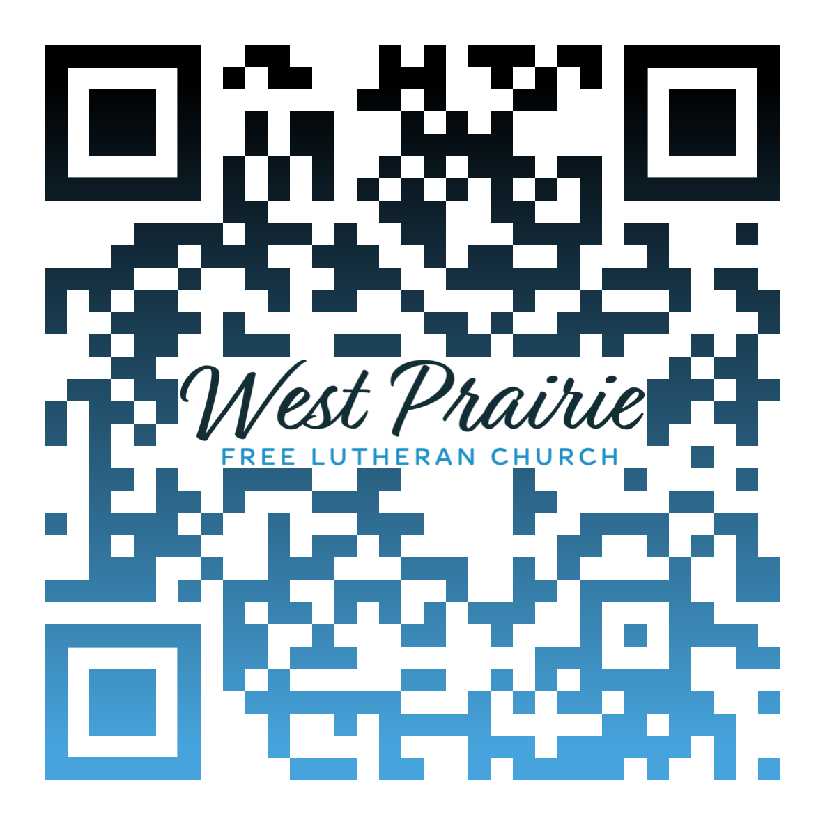
*Have any questions or needs, call Pastor Ryan at 701-429-7101

“Please take a number. We will serve you in the order you arrived.”
“Your call is important to us. Please stay on the line. The next representative will be with you in 87 minutes.”
“This email address is unmonitored. Replies to this address will not be responded to.”
In our hyper-connected world, it’s easy to feel like we’re yelling into the void and waiting in vain for someone to hear us, to listen to us, to take our requests seriously. We beg to be understood, to be known, to feel human. We crave connection and togetherness—a sense of purpose and belonging.
In Philippians 4:6, Paul welcomes believers to connect with Someone greater than themselves, to bring our burdens and struggles, our trials and concerns, our sins and our regrets to Him.
“Do not be anxious about anything, but in everything by prayer and supplication with thanksgiving let your requests be made known to God” (Philippians 4:6 ESV).
Think on that, brothers and sisters: Let your requests be made known to God. The Lord God—the One who spun countless galaxies into existence with just His Word, the One who thought up the axolotl and the duck-billed platypus, the One who breathed life into all mankind—wants to hear your voice. And He invites you to connect with Him in prayer and in His Word. He wants to know you. But more than that, He wants you to know Him and His Son who gave Himself on the cross for you.
There’s nothing too large or too small for Him to handle. He invites us to pray to Him in everything. That big, career make-or-break decision? Yes! Which college or vo-tech school to attend? Yep. Whether or not to pursue that particular gal? Absolutely. Should I grab fast-food for lunch or pack my own? Sure, you can pray about that, too (but also use some God-given common sense).
This causes us to rely not on our own strength or wisdom, but on the Lord God. We begin to realize that our sufficiency is not in and of ourselves, but it flows from Him. As a result, the exhortation to “not be anxious about anything” becomes a bit easier as we begin to realize that “He’s got the whole world in His hands.”
So, brothers and sisters, come boldly before God’s throne with your requests. It’s a throne of grace, and He longs to meet you there.

Pr. Ryan Tonneson
AFLC Youth Board Chair
Cokato, Minnesota

AFLC Promotion for May is Youth Ministries

HIDDEN TEXT

West Prairie Free Lutheran Church (AFLC)
Making the Gospel Known
15720 Highway 46 and 18 S. Kindred ND 58051
Pastor Ryan Patenaude 701-429-7101
https://westprairieaflc.com

