West Prairie Free Lutheran Church
Worship Service 9:30 a.m.
Trinity Sunday – May 31st, 2026

Prelude – Welcome – Announcements
Call to Worship Psalm 34:1-3
I will bless the Lord at all times; his praise shall continually be in my mouth. My soul makes its boast in the Lord; let the humble hear and be glad. Oh, magnify the Lord with me, and let us exalt his name together!
Hymn All Creatures of our God and King Hymn 183
Praises and Prayer Requests
Confession of Sin
Dear Heavenly Father, we come before you to confess to you that we have grievously sinned and fallen short of your glory. We have not loved you above all things or our neighbors as ourselves. We confess these and other sins to you in order to receive your forgiveness and cleansing. Grant to us your mercy and grace, and help us to live our lives in the way that honors you most. We pray this in the Name of Jesus, Amen.
Declaration of Grace
Worship Song Projected
Scripture Readings Psalm 8 Pew Bible 450 Matthew 28:16-20 Pew Bible 835
Confession of Faith Athanasian Creed Insert
Offering
Hymn Now I Belong to Jesus Hymn 546
Message A Foolish Husband 1 Samuel 25:1-13 Pew Bible 247
Hymn Nearer, My God, To Thee Hymn 602
The Lord’s Prayer
Benediction & Doxology Hymn 390

This week at West Prairie (May 31 – June 7)
2:30 p.m. Decorate for VBS!
Mon 7:00 p.m. Council Meeting
Tues 6:00 a.m. Women’s Walking (Meeting at Kindred Elem.)
Sun 9:30 a.m. Worship Service

VBS:
Mon- Thurs
3:00 – 5:00 p.m. VBS
Thurs 5:00 p.m. VBS Program
5:30 p.m. Pot blessing

ANNOUNCEMENTS
VBS: It’s here!! Programming will run 3:00-5:00 p.m. June 1-4. There will be a program at 5:00 p.m. on Thursday, June 4 and a potluck meal following at 5:30 p.m. If you would be willing to serve that potluck meal, please let Allie or Brenna know!

Annual Conference: Registration for annual conference price increases after May 31st. The registration can be found at the QR code on the next page. The conference theme is “Sure Hope” based on Philippians 1:6. Here is the layout:
Wednesday, June 10- WMF Day + 7:00 p.m. Conference Opening
Thursday, June 11 through Saturday June 13 – Conference all day

Wilderness Retreat: The FOURTH annual wilderness retreat registration is open! Lots of information at the QR on the tear-off.

Reader next Sunday: Debby Strand
Ushers next Sunday: Larsen Family
Custodians for June: Ness and Young
Mower this week: Kent Sannes

How to give:
Offering
https://westprairieaflc.com/donate/

Planning Center App found at this QR Code:

Giving Update:
April Giving: $13,040.05
Monthly Budget: $14,208.33
Yearly Giving: $62,255.01
Yearly Budget: $56,833.32

Narthex resources to take home:
West Prairie Visitor Book
Lutheran Ambassador
West Prairie Directory
West Prairie Service Booklet

Happy Birthday To:

1st - Calvin Woodbury
2nd - Carrie Richardson
5th - Nina Richardson


Future Dates:
- VBS (June 1-4)

- Annual Conf. (June 10-13)


- Wilderness Retreat (August 13-16)


Cookbook
We have a West Prairie church cookbook for sale! If you would like to buy one- there is a sign-up in the Narthex. Payments can be made via cash or check to West Prairie Building Fund or on the Planning Center App indicated for the Building Fund.

Missionary of the Month
Name: Zachariah & Carey Ritland
Serving: Paraguay
Prayer Requests: 1) Praise for their new son, Jericho’s birth! 2) Endurance as they continue to learn Spanish 3) Praise for 8 baptisms in their church the past month and that they would continue to grow in faith and devotion to the Lord 4) Paperwork to get their Paraguayan ID cards

June Monthly Bible Studies
Women: June 15th at 7:00 p.m.
Women: June 11th at 10:00 a.m.
Men: June 16th at 7:00 p.m.

Are you new here?
*Announcements, prayer requests, serving opportunities get sent out via email and text! We would love to get you in the loop. You can sign up by going to www.wpfl.flocknote.com or by scanning this QR Code:
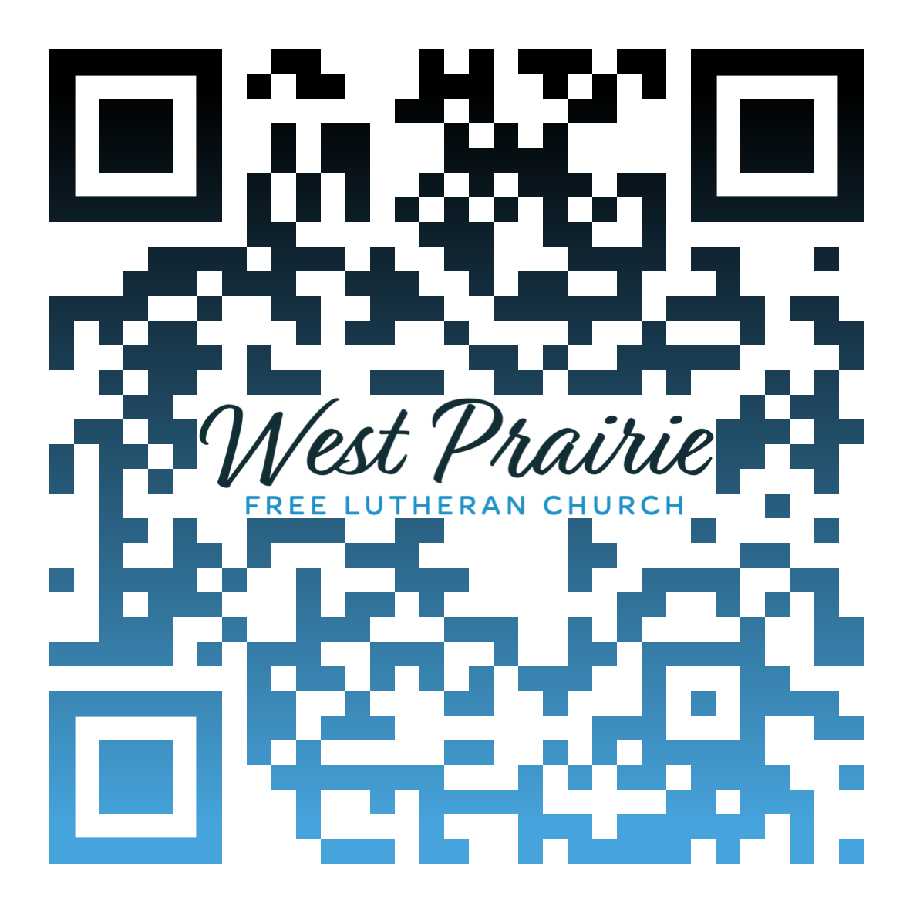
*Have any questions or needs, call Pastor Ryan at 701-429-7101

Have you ever been thirsty? Like, lost-in-the-Sahara kind of thirsty? Personally, I get thirsty pretty easily. When I forget to bring my water bottle somewhere, it only takes a few minutes before I start anxiously scanning my surroundings for a water source. In an ideal world (if, say, someone invented an auto-refilling water bottle), I wouldn’t need to worry about my next drink.
What if I told you that our King has provided a better gift than even my water-crazy brain could have imagined? Jesus once cried, “If anyone thirsts, let him come to me and drink” (John 7:37b ESV). Yet Jesus was offering more than a cup of water to a dusty crowd. Jesus went on to say, “Whoever believes in me, as the Scripture has said, ‘Out of his heart will flow rivers of living water’” (John 7:38 ESV). John clarifies that this living water was to be delivered courtesy of the Holy Spirit, who was yet to come, because Jesus had not finished His mission.
Why does this matter to you? Jesus’ offer of renewable refreshment hits at a core need that both you and I have: without Him, we can do nothing (John 15:5). Jesus offers spiritual life not just in a one-time exchange, but as an ongoing connection to the Triune Life-giver. If you’ve been united to Christ through faith in His work applied through water and the Word (Romans 6:5), then the same Holy Spirit who renewed you (Titus 3:5) now intercedes for you from within you (Romans 8:26), since He is the guarantee of Jesus’ promises (2 Corinthians 1:22). If the Holy Spirit didn’t graciously continue to nourish you, even your efforts to know God through His Word would be in vain (1 Corinthians 2:14). But praise God that He pours out His love into our hearts through His Spirit like an overflowing fountain every time we receive His Word (Romans 5:5).
With temperatures heating up, you know you’ll need to hydrate your body this summer. Don’t then neglect God’s call to come and drink deeply, without cost, from the living waters that His Son opened through His death and resurrection for you (Isaiah 55:1). Prioritize time in God’s Word this summer just like you’d prioritize a cool beverage on a sunny day. I guarantee that the refreshment that Christ offers by His Spirit through His Word will last longer than even the coldest bottle of water.

Pr. Joseph Larson
Christ the King Free Lutheran Church
Pipestone, Minnesota

AFLC Promotion for May is Youth Ministries

HIDDEN TEXT

West Prairie Free Lutheran Church (AFLC)
Making the Gospel Known
15720 Highway 46 and 18 S. Kindred ND 58051
Pastor Ryan Patenaude 701-429-7101
https://westprairieaflc.com

