West Prairie Free Lutheran Church
Worship Service 9:30 a.m.
Ninth Sunday after Trinity– August 2nd, 2026

Prelude – Welcome – Announcements
Call to Worship Psalm 100
Make a joyful noise to the Lord, all the earth! Serve the Lord with gladness! Come into his presence with singing! Know that the Lord, he is God! It is he who made us, and we are his; we are his people, and the sheep of his pasture. Enter his gates with thanksgiving, and his courts with praise! Give thanks to him; bless his name! For the Lord is good; his steadfast love endures forever, and his faithfulness to all generations.
Hymn Alleluia! Sing to Jesus Hymn 118
Praises and Prayer Requests
Confession of Sin Silent Prayer
Declaration of Grace
Worship Song Projected
Scripture Readings Isaiah 55:1-5 Pew Bible 615 Matthew 14:13-21 Pew Bible 820
Confession of Faith Nicene Creed Hymnal p 32
Offering
Hymn My Jesus, I Love Thee Hymn 193
Message Greetings Romans 16:1-16 Pew Bible 950
Hymn Break Thou the Bread of Life Hymn 257
Celebration of the Lord’s Supper
The Lord’s Prayer
Benediction & Doxology Hymn 390

This week at West Prairie (August 2 – August 9)
TODAY Pre-Teen camp begins!
Mon 7:00 p.m. Council Meeting
Sat Pancake Feed
Sun 9:30 a.m. Worship Service

ANNOUNCEMENTS
Wilderness Retreat: Food sign-ups went out this week for wilderness retreat! Let Brenna know if you didn’t get that email and want to join!

Pancake Feed: The annual Kindred Days pancake feed is this Saturday. There is a sign-up sheet in the Narthex for set up, cooking, cleaning, and serving! Let us know if you are willing to help. This has been a great community event and fundraiser the past couple of years!

Small Groups this Fall: This fall we are doing small groups differently. Hosts will decide when (and how long) to meet and what to study. Hopefully, we will have enough hosts to provide a few different options for those who want to participate. If you would be interested in hosting but need some ideas on what to study, Pastor Ryan would love to help. Please consider hosting a small group—on your terms. Talk to Pastor Ryan if you are willing to host one or have any questions.

Reader next Sunday: Malena Dubovoy
Ushers next Sunday: Jared and Jennifer Ness
Custodians for August: Strand Family
Mower this week: Mark Larsen

How to give:
Offering
https://westprairieaflc.com/donate/

Planning Center App found at this QR Code:

Giving Update:
June Giving: $14,068.03
Monthly Budget: $14,208.33
Yearly Giving: $94,323.04
Yearly Budget: $85,249.98

Narthex resources to take home:
West Prairie Visitor Book
Lutheran Ambassador
West Prairie Directory
West Prairie Service Booklet


Happy Birthday To:
4th - Laura Berg
6th - Ryan Patenaude
7th - Grace Guzik

Happy Anniversary To:
6th – Ron & Stacy Ness
6th – Andrew & Brenna Berge

Upcoming Dates:
Youth Group Kick-off- August 26th
WOW Carnival- September 2nd
Confirmation Begins- September 9th
Rally Sunday- September 13th
New Member Class- 9/20 – 10/11

Cookbook
We have a West Prairie church cookbook for sale! If you would like to buy one- there is a sign-up in the Narthex. Payments can be made via cash or check to West Prairie Building Fund or on the Planning Center App indicated for the Building Fund.

August Monthly Bible Studies
Women: August 17th at 7:00 p.m.
Women: August 13th at 10:00 a.m.
Men: August 18th at 7:00 p.m.

Are you new here?
*Announcements, prayer requests, serving opportunities get sent out via email and text! We would love to get you in the loop. You can sign up by going to www.wpfl.flocknote.com or by scanning this QR Code:
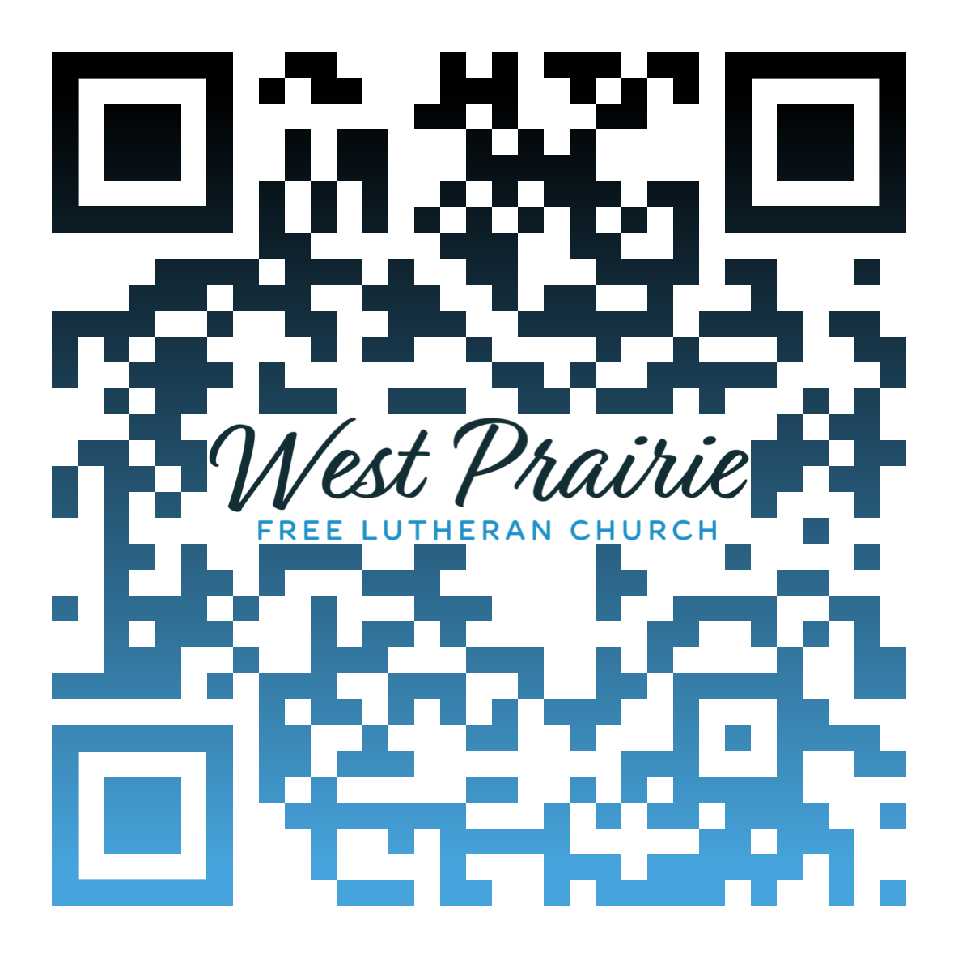
*Have any questions or needs, call Pastor Ryan at 701-429-7101

I grew up with the basic “confirmation” definition of grace and mercy. Grace is getting what you don’t deserve (in a positive sense), and mercy is not getting what you do deserve (in a negative sense).
I think the concept of grace can be fairly easy to understand for many of us who are gift givers. It is a natural way for me to express love by giving gifts. Gift giving can be a way of expressing thanks, but it can also simply be a way of providing someone with enjoyment. I delight in choosing a gift that will make someone happy in just the right way.
Mercy, however, is a different beast altogether. Mercy is easy to clamor for when we’re in need of it, but it is incredibly hard to dole out when we are the offended party. Our sense of righteous indignation often gets in the way of our mercy.
Mercy and forgiveness are the topics of Jesus’ parable in Matthew 18:21-35. A certain king forgives an unfathomable amount of money to a servant. The servant owed him 10,000 talents, and a talent was equivalent to twenty years’ worth of wages for a laborer. You can do the math if you choose.
As the servant begged the king to give him even an opportunity to pay him back, the king chose simply to forgive the debt. He was merciful and simply sent the servant on his way.
The servant, in turn, encountered someone who owed him money. This debt of a hundred denarii (a denarii was the equivalent of a day’s wage) was significant, but not insurmountable. Rather than extend the servant the same mercy he received from the king, the first servant physically accosted the debtor and had him thrown into prison.
Jesus’ parable ends with the king discovering the situation, reversing his decision, and throwing the first servant into prison. “You wicked servant! I forgave you all that debt because you pleaded with me. And should not you have had mercy on your fellow servant, as I had mercy on you?” (Matthew 18:32-33).
A lack of mercy on our part betrays a lack of understanding of the Gospel. We do not deserve the forgiveness Christ won for us on the cross. God did not need to send Him to take our place. But He did, and our salvation and our eternities are bound up in His mercy.
May we all be found extending that mercy to those who have offended us.

Dr. Jason Gudim
AFLC Schools Faculty
Plymouth, Minnesota

AFLC Promotion for August is the Seminary

HIDDEN TEXT

West Prairie Free Lutheran Church (AFLC)
Making the Gospel Known
15720 Highway 46 and 18 S. Kindred ND 58051
Pastor Ryan Patenaude 701-429-7101
https://westprairieaflc.com

