West Prairie Free Lutheran Church
Worship Service 9:30 a.m.
Eighth Sunday after Trinity– July 26th, 2026

Prelude – Welcome – Announcements
Call to Worship Psalm 149:1,3-5
Praise the Lord! Sing to the Lord a new song, his praise in the assembly of the godly! Let them praise his name with dancing, making melody to him with tambourine and lyre! For the Lord takes pleasure in his people; he adorns the humble with salvation. Let the godly exult in glory; let them sing for joy on their beds.
Hymn Stand Up, Stand Up For Jesus Hymn 456
Praises and Prayer Requests
Confession of Sin
Have mercy on me, O God, according to your steadfast love; according to your abundant mercy blot out my transgressions. Wash me thoroughly from my iniquity, and cleanse me from my sin! For I know my transgressions, and my sin is ever before me. Against you, you only, have I sinned and done what is evil in your sight, so that you may be justified in your words and blameless in your judgment.
Declaration of Grace
Worship Song Projected
Scripture Readings Psalm 125 Pew Bible 517 Matthew 13:44-52 Pew Bible 819
Confession of Faith Apostles' Creed Hymnal p 32
Offering
Hymn Take Time To Be Holy Hymn 481
Message Guest Speaker
Hymn At Calvary! Hymn 533
The Lord’s Prayer
Benediction & Doxology Hymn 390

This week at West Prairie (July 26 – August 2)
TODAY Teen camp begins!
Sun 9:30 a.m. Worship Service
Pre-Teen camp begins!

ANNOUNCEMENTS
Pancake Feed: The annual Kindred Days pancake feed is on the morning of August 8th. There is a sign-up sheet in the Narthex for set up, cooking, cleaning, and serving! Let us know if you are willing to help. This has been a great community event and fundraiser the past couple of years!

Small Groups this Fall: This fall we are doing small groups differently. Hosts will decide when (and how long) to meet and what to study. Hopefully, we will have enough hosts to provide a few different options for those who want to participate. If you would be interested in hosting but need some ideas on what to study, Pastor Ryan would love to help. Please consider hosting a small group—on your terms. Talk to Pastor Ryan if you are willing to host one or have any questions.

Reader next Sunday: Andrew Berge
Ushers next Sunday: Lucas and Amanda Vangsness
Custodians for July: Murphy Family
Mower this week: Andrew Berge

How to give:
Offering
https://westprairieaflc.com/donate/

Planning Center App found at this QR Code:

Giving Update:
June Giving: $14,068.03
Monthly Budget: $14,208.33
Yearly Giving: $94,323.04
Yearly Budget: $85,249.98

Narthex resources to take home:
West Prairie Visitor Book
Lutheran Ambassador
West Prairie Directory
West Prairie Service Booklet


Happy Birthday To:
TODAY – Ann Huether
27th – Vince Guzik
27th – Bobbi Woodbury
28th – Paula Woodbury
29th – Tony Scherer
29th – Warren Woodbury
30th – Scarlett Sannes
1st – Shawnette Kommer

Happy Anniversary To:
TODAY- Nathaniel & Joanna Olson
27th – Jason & Bekki DuBord

Cookbook
We have a West Prairie church cookbook for sale! If you would like to buy one- there is a sign-up in the Narthex. Payments can be made via cash or check to West Prairie Building Fund or on the Planning Center App indicated for the Building Fund.

Missionaries of the Month
AFLC Journey Mission has two missionary assistants this summer. Kyle Gorman is serving in Switzerland and Michelle Abel is serving in Brazil. Prayer requests for these two this month are: 1) health and safety 2) courage and boldness in faith and 3) guidance for future mission work

August Monthly Bible Studies
Women: August 17th at 7:00 p.m.
Women: August 13th at 10:00 a.m.
Men: August 18th at 7:00 p.m.

Are you new here?
*Announcements, prayer requests, serving opportunities get sent out via email and text! We would love to get you in the loop. You can sign up by going to www.wpfl.flocknote.com or by scanning this QR Code:
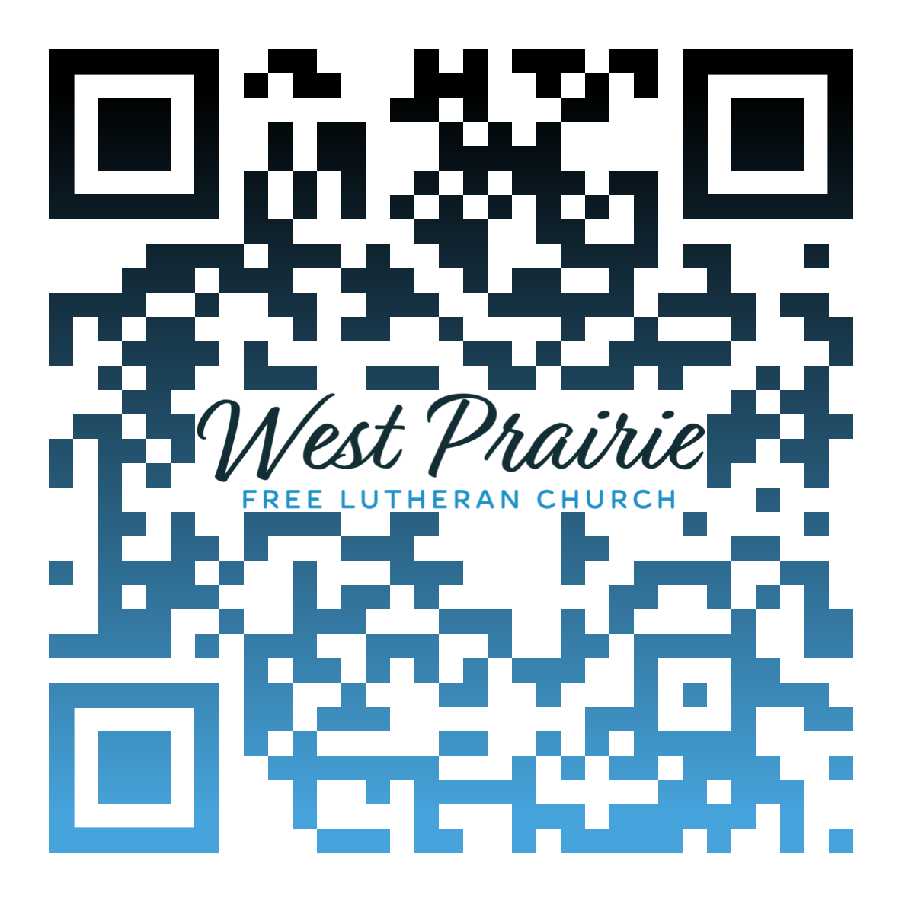
*Have any questions or needs, call Pastor Ryan at 701-429-7101

Someone to Redeem Me

I was trapped in my chair at the front of the church. The altar was right behind me. Before me were four tables seating about forty people in our little meeting place, the size of a one-car garage. We had gathered after the service for our annual tamal dinner.
The steaming meat, packed inside masa wrapped in corn husks, begged for my attention. But I was transfixed by the wonder of what I saw just inside the garage door opening. A young man sat at the table, his wife beside him. And not five feet away stood his brother-in-law. Today was the first time in five years the young man had been back to this service and meal. His brother-in-law had never attended before.
The wonder was because five years ago, the two of them had an explosion of words that very nearly came to blows. The young man sent me a plaintive message that night: “They’re accusing me of terrible things.” And who could ever know the truth? People knew the “what,” but nobody could be sure of the “why.” The young man claimed he was innocent. No one believed him.
Job’s friends didn’t believe him either. No way could someone suffer such drastic misfortunes and be innocent. He had to be guilty of something, and nothing Job could say would convince them otherwise. Job needed a Redeemer (Job 19:25); someone to set the record straight (9:33), a witness to testify to his innocence (16:19).
In our interactions with others, we might wish for an Instant Replay to show what really happened, or a Motive Scanner to reveal why we did what we did. We, too, might long for someone who can set the record straight when we are in a dispute or serve as a witness to our innocence.
But our need for a Redeemer isn’t to prove our innocence because we are innocent. We need a Redeemer because we are, in fact, guilty. We need Jesus to argue for our innocence because, as the Redeemer, He paid the price to get us out of the terrible situation we got ourselves into. God’s anger burned against us. Jesus’ blood delivered us. Instant Replay in Scripture shows the crucifixion of God’s beloved Son. A Motive Scan of God’s heart in Scripture reveals the reason why: God “loved us with an everlasting love” (Jeremiah 31:3). And Jesus’ grave is empty—end of argument.

Pastor Todd Schierkolk
AFLC Missionary
Iglesia “Un Lugar de Encuentro con Dios”
Jerez, Zacatecas, Mexico

AFLC Promotion for July is World Missions

HIDDEN TEXT

West Prairie Free Lutheran Church (AFLC)
Making the Gospel Known
15720 Highway 46 and 18 S. Kindred ND 58051
Pastor Ryan Patenaude 701-429-7101
https://westprairieaflc.com

