West Prairie Free Lutheran Church
Worship Service 9:30 a.m.
Twelfth Sunday after Trinity– August 23rd, 2026

Prelude – Welcome – Announcements
Call to Worship Psalm 150:1-2, 6
Praise the Lord! Praise God in his sanctuary; praise him in his mighty heavens! Praise him for his mighty deeds; praise him according to his excellent greatness! Let everything that has breath praise the Lord! Praise the Lord!
Hymn Love Divine, All Love Excelling Hymn 226
Praises and Prayer Requests
Confession of Sin
Lord, we confess to you that we have sinned against you with our hands, our mouths, and our thoughts. We have failed to love you with all our hearts, souls, and minds and have failed to love our neighbor as ourselves. Not only have we done what you prohibit, we have failed to do what you have commanded. We are sorry and ask for your forgiveness. Amen.
Declaration of Grace
Worship Song Projected
Scripture Readings Isaiah 51:1-6 Pew Bible 611 Matthew 16:13-20 Pew Bible 822
Confession of Faith Apostles’ Creed Hymnal p 32
Offering
Hymn Breathe On Me, Breath of God Hymn 133
Message The Doxology Romans 16:25-27 Pew Bible 951
Hymn Rock of Ages, Cleft For Me Hymn 398
The Lord’s Prayer
Benediction & Doxology Hymn 390

This week at West Prairie (August 23 – August 30)
TODAY 7:00 p.m. Back to School Prayer Night at KPAC
Wed 6:00 p.m. Youth Group Kick-off at Patenaudes!
Sun 9:30 a.m. Worship Service

ANNOUNCEMENTS
Prayer Night: There is a community back to school prayer night happening at the KPAC at the Kindred High School tonight at 7:00 p.m. Come join in prayer for this upcoming school year!

Wilderness Retreat: We took an offering for a camp donation and a pastoral memorandum last Sunday. For those who wanted to give and did not have means while at camp, you can give your donation in the offering today designated for AFLC Wilderness Camp. Mark your calendars for next summer August 19-22 for year FIVE!

Small Groups this Fall: We are still looking for more small group hosts this fall. We will have sign-ups out for small groups on Rally Sunday, September 13th! Talk to Pastor Ryan if you are interested!

Youth Group Kick-off will be at the Patenaude home on August 26th from 6-8. There will be dinner provided!

WOW Carnival: Our Wednesday Night K-6 program will be kicking off with a family carnival night on September 2nd from 5-7. Bring the family for carnival games, balloon animals, cotton candy, hair tinsel, and a fun night!

New Member Class: Interested in becoming a member at West Prairie? Pastor Ryan will be teaching a new membership class September 20-October 11 at 9:15 on Sunday mornings. Let him know if you are interested in attending!

Rally Sunday will be on September 13th!

Confirmation will begin on September 9th!

Reader next Sunday: Debby Strand
Ushers next Sunday: Kommer Family
Custodians for August: Strand Family
Mower this week: Kent Sannes

How to give:
Offering
https://westprairieaflc.com/donate/

Planning Center App found at this QR Code:

Giving Update:
June Giving: $14,068.03
Monthly Budget: $14,208.33
Yearly Giving: $94,323.04
Yearly Budget: $85,249.98

Narthex resources to take home:
West Prairie Visitor Book
Lutheran Ambassador
West Prairie Directory
West Prairie Service Booklet


Happy Birthday To:
23rd - Ethan Kommer
24th - Ivory Woodbury
27th - Allison Solseth

Happy Anniversary To:
24th – Dennis & Tammy Jones

Cookbook
We have a West Prairie church cookbook for sale! If you would like to buy one- there is a sign-up in the Narthex. Payments can be made via cash or check to West Prairie Building Fund or on the Planning Center App indicated for the Building Fund.

August Monthly Bible Studies
Women: Sep. 21st at 7:00 p.m.
Women: Sep. 10th at 10:00 a.m.
Men: Sep. 15th at 7:00 p.m.

Are you new here?
*Announcements, prayer requests, serving opportunities get sent out via email and text! We would love to get you in the loop. You can sign up by going to www.wpfl.flocknote.com or by scanning this QR Code:
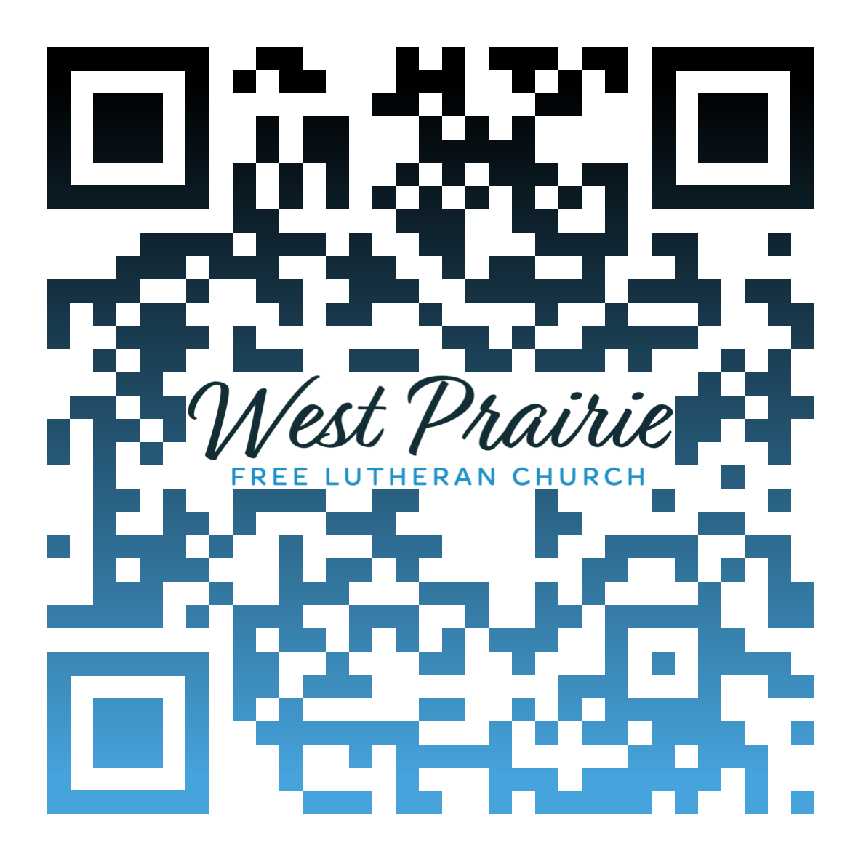
*Have any questions or needs, call Pastor Ryan at 701-429-7101

Nest-less Birds
How long are you able to live out of a suitcase before you’re sick of it? Most people I know love leaving home for vacation but, within a week or two, yearn to get back and sleep in their “own beds.” This desire for the comforts of home appears universal and timeless.
Jesus knew this when He responded to the scribe in Matthew 8:20. Scribes were among the most educated men in first century Israel. Their particular skill set—reading, writing, and teaching the law—made them highly valuable in Israelite society and afforded them a lifestyle of maximum security and stability. So, when the scribe boldly announces his intent to follow Jesus wherever He goes, Jesus colorfully reminds him of what he’ll give up. Jesus says, “the birds of the air have nests, but the Son of Man has nowhere to lay his head.” In other words, if you follow Me, you’re going to be living out of a suitcase.
Matthew 8:20 is the second time Jesus points out “the birds of the air” in Matthew’s Gospel. The first time, Jesus cites birds as examples of freedom from worry. “Look at the birds of the air,” He says. “They neither sow nor reap nor gather into barns, and yet your heavenly Father feeds them” (Matthew 6:26). Contemplating Jesus’ instruction, we rejoice, imagining a delightful life of chipper morning songfests and blue-sky days feeling “free as a bird.” Less enticing on the surface is the picture Jesus gives us of discipleship in Matthew 8:20. It’s a life without the security and stability of a home base. Even “birds of the air have nests, but the Son of Man has nowhere to lay his head.”
Reading the two Matthew passages together, we see that Jesus is calling His followers to a life of freedom from worry but with no guarantee of conventional sources of security and stability. In short, Jesus is calling His people to a life of simple trust in Him.
One of the greatest examples of this trust is the Apostle Paul. He lived the second half of his life like a nest-less bird. For decades on end, he lived out of a suitcase. But listening to Paul describe his life following Jesus, we hear no complaint. Instead, we hear birdsong and sense freedom; we note tones of deep security and stability. As Paul joyfully tells the Philippian Christians, the secret Jesus taught him for such a free but secure life is this: “I can do all things through Christ who strengthens me.” It’s the lesson Jesus will teach us, too, if we’re willing to echo the scribe and say, Lord Jesus, “I will follow you wherever you [lead].”

Dr. Brent Olson
AFLC Schools Faculty
Plymouth, Minnesota

AFLC Promotion for August is the Seminary

HIDDEN TEXT

West Prairie Free Lutheran Church (AFLC)
Making the Gospel Known
15720 Highway 46 and 18 S. Kindred ND 58051
Pastor Ryan Patenaude 701-429-7101
https://westprairieaflc.com

