West Prairie Free Lutheran Church
Worship Service 9:30 a.m.
Thirteenth Sunday after Trinity– August 30th, 2026

Prelude – Welcome – Announcements
Call to Worship Psalm 95:1-3
Oh come, let us sing to the Lord; let us make a joyful noise to the rock of our salvation! Let us come into his presence with thanksgiving; let us make a joyful noise to him with songs of praise! For the Lord is a great God, and a great King above all gods.
Hymn Praise to the Father, The Glorious King Hymn 140
Praises and Prayer Requests
Confession of Sin
Have mercy on me, O God, according to your steadfast love; according to your abundant mercy blot out my transgressions. Wash me thoroughly from my iniquity, and cleanse me from my sin! For I know my transgressions, and my sin is ever before me. Against you, you only, have I sinned and done what is evil in your sight, so that you may be justified in your words and blameless in your judgment.
Declaration of Grace
Worship Song Projected
Scripture Readings Jeremiah 15:15-21 Pew Bible 643 Matthew 16:21-28 Pew Bible 822
Confession of Faith Apostles’ Creed Hymnal p 32
Offering
Hymn Savior, Like a Shepherd Lead Us Hymn 450
Message The Battle Belongs to the Lord 1 Samuel 26 Pew Bible 249
Hymn What Can Wash Away My Sin Hymn 557
The Lord’s Prayer
Benediction & Doxology Hymn 390

This week at West Prairie (August 30 – September 6)
TODAY 4:00 p.m. Visitation
5:00 p.m. Prayer Service for Eva Richardson
Mon 11:00 a.m. Funeral Service for Eva Richardson
Wed 5:00 p.m. WOW Carnival
7:00 p.m. Youth Group
Sun 9:30 a.m. Worship Service

ANNOUNCEMENTS
Eva Richardson: There will be a prayer service tonight at 5:00 p.m. and funeral tomorrow, Monday August 31 at 11:00 a.m. for Eva Richardson.
Matt Andvik: There is a celebration of life for Matt Andvik on September 12th at 12:00 – 1:00 p.m. at Kindred Lutheran Church with a lunch to follow.
Small Groups this Fall: We are still looking for more Small Group hosts this fall. We will have sign-ups out for small groups on Rally Sunday, September 13th! Talk to Pastor Ryan if you are interested!
WOW Carnival: Our Wednesday Night K-6 program will be kicking off with a family carnival night this Wednesday from 5-7. Bring the family for carnival games, balloon animals, cotton candy, hair tinsel, and a fun night!
New Member Class: Interested in becoming a member at West Prairie? Pastor Ryan will be teaching a new membership class September 20-October 11 at 9:15 on Sunday mornings. Let him know if you are interested in attending!
Rally Sunday will be on September 13th! Our service time will change back to 10:30 a.m. and Sunday School at 9:15 a.m.
Confirmation will begin on September 9th!
WMF Fall Rally: The district WMF Fall Rally is being held at Ebenezer Free Lutheran Church in Northwood on September 19th starting at 9:30 a.m. Registration is $15 which includes a luncheon. There will be speakers and devotionals and lots of good fellowship!
Cookie Fellowship: We are going to be back to having cookie fellowship on Sunday mornings on September 20th! If you are interested in signing up to bring cookies- check out the sign-up in the Narthex!
REEL CHILI: Another chili cookoff and movie night is scheduled for October 3rd. More information to come!

Reader next Sunday: Keegan Murphy
Ushers next Sunday: Ron and Stacy Ness
Custodians for September: Jones & Paula Woodbury
Mower this week: Andrew Berge

How to give:
Offering
https://westprairieaflc.com/donate/

Planning Center App found at this QR Code:

Giving Update:
June Giving: $14,068.03
Monthly Budget: $14,208.33
Yearly Giving: $94,323.04
Yearly Budget: $85,249.98

Narthex resources to take home:
West Prairie Visitor Book
Lutheran Ambassador
West Prairie Directory
West Prairie Service Booklet


Happy Birthday To:
TODAY – Tammy Jones
31st – Viola Schrader
2nd – Libby McDonald
4th – Logan Mauch

Happy Anniversary To:
1st – Clarissa & Jerod Gemar
2nd – Isaac & Malena Dubovoy
3rd – Lucas & Amanda Vangsness

Cookbook:
We have a West Prairie church cookbook for sale! Payments of $25 can be made via cash or check designated to West Prairie Building Fund or on the Planning Center App indicated for the Building Fund. The extra books are in boxes in the Narthex.
September Monthly Bible Studies
Women: Sep. 21st at 7:00 p.m.
Women: Sep. 10th at 10:00 a.m.
Men: Sep. 15th at 7:00 p.m.

Youth Group
*Updates and announcements regarding youth group are sent via the band app. If you want to be in the loop check out this QR code:


Are you new here?
*Announcements, prayer requests, serving opportunities get sent out via email and text! We would love to get you in the loop. You can sign up by going to www.wpfl.flocknote.com or by scanning this QR Code:
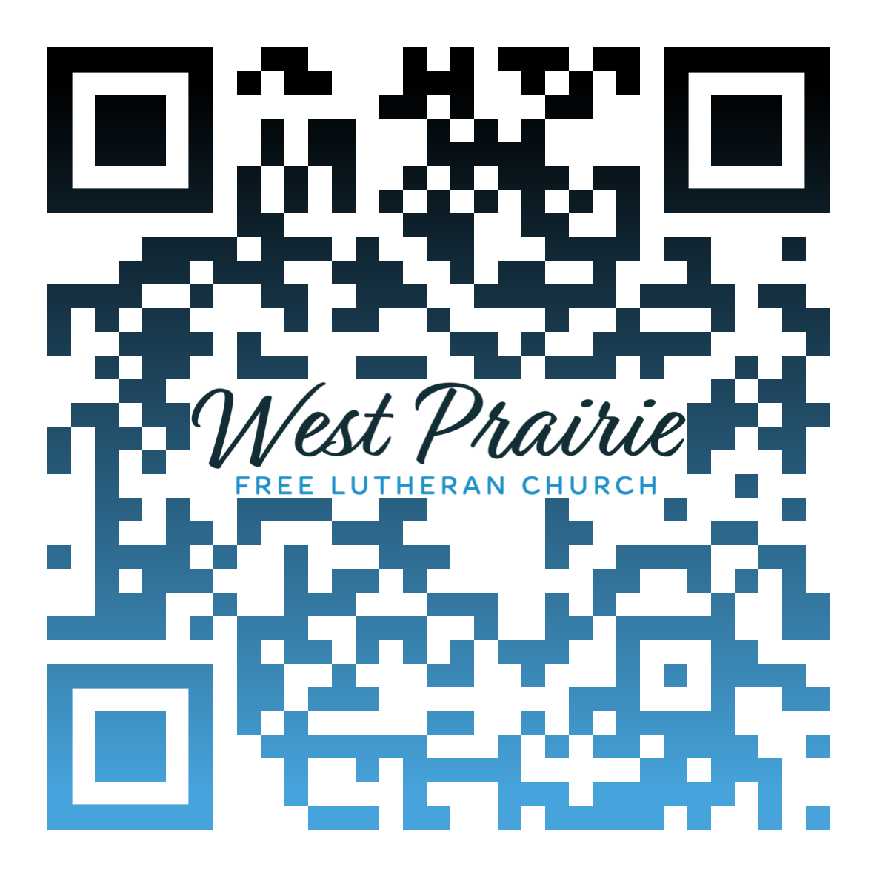
*Have any questions or needs, call Pastor Ryan at 701-429-7101

A call to holiness is God’s invitation for us to “commit our ways to Him” (Psalm 37:5). It’s a recognition that “We are his workmanship, created in Christ Jesus for good works, which God prepared beforehand, that we should walk in them” (Ephesians 2:10).
Now, some would perhaps scoff and say that a focus on holiness sounds rather legalistic. However, this emphasis need not denigrate into legalism. It is simply a call to live life in response to what God has done for us—that we would love because He first loved us (1 John 4:19).
Jesus says it this way: “If you love me, you will keep my commandments” (John 14:15). In looking at this passage, it doesn’t seem like Jesus is saying this arbitrarily or as a means to show us our inability. It seems that what Jesus really wants is for us to live in conformity to the will of God.
In the same way, if I ask my nine-year-old to clean his room, do I want him to come back and say, “Dad, I memorized exactly what you said: ‘Clean your room’”? Or would I tolerate him coming back and saying, “Dad, I got a bunch of my friends together for a small group study on what it means to clean my room”? How about if he comes and says, “Dad, I learned how to say ‘clean your room’ in Greek”?
No! I want him to actually go and do what I told him to do! I want him to clean His room.
In the same manner, God has given us the revelation of His will for our lives—how to love and serve our neighbors; how to reflect Him to the world around us.
Therefore, as ambassadors for Christ, as a city on a hill, we go forth committing our ways to the Lord—living lives of holiness. Not to earn or merit God’s favor, but because of a life changed by the favor God has shown to us through His Son Jesus Christ.

Dr. Nathan Olson
AFLC Schools Faculty
Plymouth, Minnesota

AFLC Promotion for August is the Seminary

HIDDEN TEXT

West Prairie Free Lutheran Church (AFLC)
Making the Gospel Known
15720 Highway 46 and 18 S. Kindred ND 58051
Pastor Ryan Patenaude 701-429-7101
https://westprairieaflc.com

