West Prairie Free Lutheran Church
Worship Service 9:30 a.m.
Tenth Sunday after Trinity– August 9th, 2026

Prelude – Welcome – Announcements
Call to Worship Psalm 117
Praise the Lord, all nations! Extol him, all peoples! For great is his steadfast love toward us, and the faithfulness of the Lord endures forever. Praise the Lord!
Hymn And Can It Be That I Should Gain Hymn 404
Praises and Prayer Requests
Confession of Sin
Dear Heavenly Father, we come before you to confess to you that we have grievously sinned and fallen short of your glory. We have not loved you above all things or our neighbors as ourselves. We confess these and other sins to you in order to receive your forgiveness and cleansing. Grant to us your mercy and grace, and help us to live our lives in the way that honors you most. We pray this in the Name of Jesus, Amen.
Declaration of Grace
Worship Song Projected
Scripture Readings Job 38:4-18 Pew Bible 443 Matthew 14:22-33 Pew Bible 820
Confession of Faith Apostles’ Creed Hymnal p 32
Offering
Hymn O Word of God Incarnate Hymn 263
Message Watch Out Romans 16:17-23 Pew Bible 950
Hymn I Am Thine, O Lord Hymn 471
The Lord’s Prayer
Benediction & Doxology Hymn 390

This week at West Prairie (August 9 – August 16)
Mon 6:00 p.m. JOY Committee Meeting
Thurs-Sun Wilderness Retreat!
Sun 10:00 a.m. Worship Service held at Wilderness Camp

ANNOUNCEMENTS
Wilderness Retreat: IT”S HERE!!! Some schedule highlights for those planning to join for parts of the weekend.
- Friday: 5:00 communal supper, 6:30 service, evening bonfire
- Saturday
  - 10:00 Cornhole (sign-up at Friday service or let Brenna know)
  - 12:00 communal lunch
  - Afternoon swimming and beach games, pickleball
  - 5:00 communal supper
  - 6:30 service
  - Bonfire and night games
- Sunday
  - 10:00 Worship Service
  - Approximately 11:30 Pot-blessing meal
Small Groups this Fall: This fall we are doing small groups differently. Hosts will decide when (and how long) to meet and what to study. Hopefully, we will have enough hosts to provide a few different options for those who want to participate. If you would be interested in hosting but need some ideas on what to study, Pastor Ryan would love to help. Please consider hosting a small group—on your terms. Talk to Pastor Ryan if you are willing to host one or have any questions.

Custodians for August: Strand Family
Mower this week: Kent Sannes

How to give:
Offering
https://westprairieaflc.com/donate/

Planning Center App found at this QR Code:

Giving Update:
June Giving: $14,068.03
Monthly Budget: $14,208.33
Yearly Giving: $94,323.04
Yearly Budget: $85,249.98

Narthex resources to take home:
West Prairie Visitor Book
Lutheran Ambassador
West Prairie Directory
West Prairie Service Booklet


Happy Birthday To:
12th - Rayna Larsen

Happy Anniversary To:
11th – Jamie & Amy Bakken

Upcoming Dates:
Youth Group Kick-off- August 26th
WOW Carnival- September 2nd
Confirmation Begins- September 9th
Rally Sunday- September 13th
New Member Class- 9/20 – 10/11

Cookbook
We have a West Prairie church cookbook for sale! If you would like to buy one- there is a sign-up in the Narthex. Payments can be made via cash or check to West Prairie Building Fund or on the Planning Center App indicated for the Building Fund.

August Monthly Bible Studies
Women: August 17th at 7:00 p.m.
Women: August 13th at 10:00 a.m.
Men: August 18th at 7:00 p.m.

Are you new here?
*Announcements, prayer requests, serving opportunities get sent out via email and text! We would love to get you in the loop. You can sign up by going to www.wpfl.flocknote.com or by scanning this QR Code:
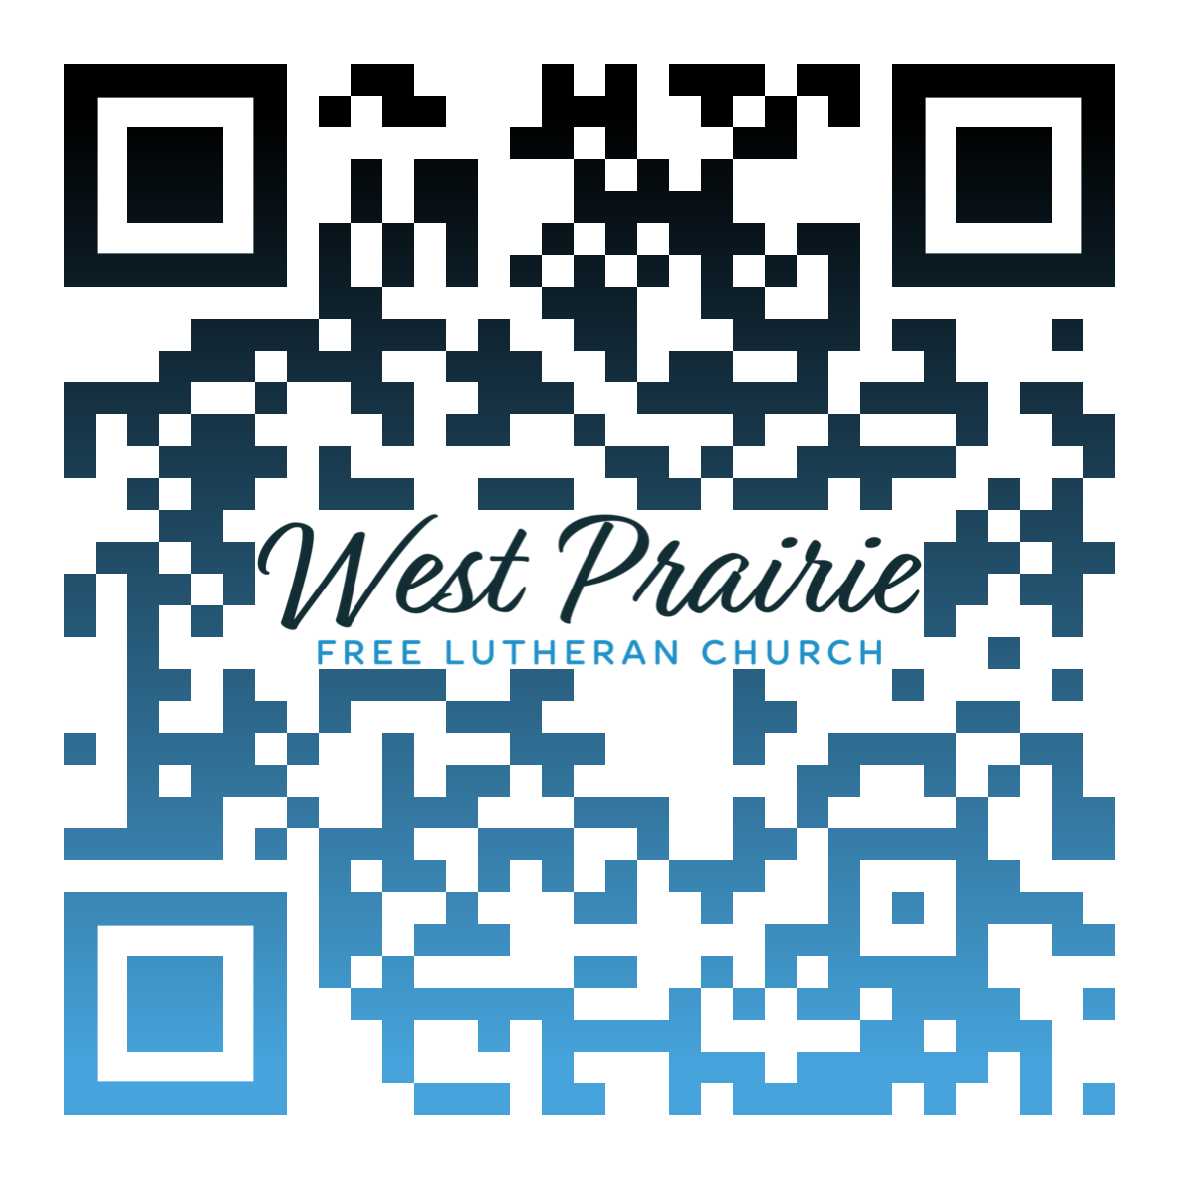
*Have any questions or needs, call Pastor Ryan at 701-429-7101

“Where were you when I established the earth? Tell me, if you have understanding.” Job 38:4
Here’s a tip: When God is asking you sarcastic, rhetorical questions, it’s best to say nothing. For the most part, Job spoke the truth about God. But there were times when he questioned God’s justice and goodness. There were times when Job justified himself and declared God to be in the wrong.
How often do we question God for how He governs the affairs of the world and, more personally, how He governs the affairs of our own lives? The truth is, we only see a fraction of a fraction of what is really happening.
In this final section of the book, God asks Job dozens of rhetorical questions, each one highlighting the gulf between God’s wisdom and Job’s finitude. Job finally responds to God: “I am so insignificant. How can I answer you? I place my hand over my mouth. . . . I spoke about things I did not understand, things too wondrous for me to know” (40:4; 42:3).
Job is never told why he was afflicted so terribly, losing his family, his livestock, and his health. (Only we, the readers, receive revelation about the behind-the-scenes interactions between Satan and God in chapters 1-2.) Although Job was never told why those things happened, I think he received something better. He heard God speak. He learned of God’s infinite wisdom. Then, he experienced how God graciously reversed his fortunes by giving him twice as much as he had once possessed.
There’s so much we don’t know about God and His governance over the world. Our perspectives are limited by our creatureliness and by our sin. Yet, God has revealed to us everything we need to know in His Word and in His Son. By God’s grace in Christ, our fortunes, too, have been reversed—receiving righteousness and adoption because Jesus bore our sin and suffered God’s wrath. We don’t (we can’t) know everything—but we know that God is wise and that He is good.
I believe Paul’s words in Romans 11:33-36 summarize what Job learned the day that God spoke to him:

Oh, the depth of the riches and wisdom and knowledge of God! How unsearchable are his judgments and how inscrutable his ways!

“For who has known the mind of the Lord,
or who has been his counselor?”
“Or who has given a gift to him
that he might be repaid?”

For from him and through him and to him are all things. To him be glory forever. Amen.

Dr. Jarrod Hylden
AFLC Schools Faculty
Plymouth, Minnesota

AFLC Promotion for August is the Seminary

HIDDEN TEXT

West Prairie Free Lutheran Church (AFLC)
Making the Gospel Known
15720 Highway 46 and 18 S. Kindred ND 58051
Pastor Ryan Patenaude 701-429-7101
https://westprairieaflc.com

