West Prairie Free Lutheran Church
Sunday School 9:15 a.m.
Worship Service 10:30 a.m.
Fifteenth Sunday after Trinity– September 13th, 2026

Prelude – Welcome – Announcements
Call to Worship Psalm 96:1-2
Oh sing to the Lord a new song; sing to the Lord, all the earth! Sing to the Lord, bless his name; tell of his salvation from day to day.
Hymn How Great Thou Art Hymn 510
Praises and Prayer Requests
Confession of Sin Psalm 51:1-7 Pew Bible 474
Have mercy on me, O God, according to your steadfast love; according to your abundant mercy blot out my transgressions. Wash me thoroughly from my iniquity, and cleanse me from my sin! For I know my transgressions, and my sin is ever before me. Against you, you only, have I sinned and done what is evil in your sight, so that you may be justified in your words and blameless in your judgment. Behold, I was brought forth in iniquity, and in sin did my mother conceive me. Behold, you delight in truth in the inward being, and you teach me wisdom in the secret heart. Purge me with hyssop, and I shall be clean; wash me, and I shall be whiter than snow.
Declaration of Grace
Worship Song Projected
Scripture Readings Genesis 50:15-21 Pew Bible 44 Matthew 18:21-35 Pew Bible 823
Confession of Faith Apostles’ Creed Hymnal p 32
Offering
Hymn O Give Us Homes Built Firm Upon The Savior Hymn 326
Message Witchcraft! 1 Samuel 28 Pew Bible 250
Hymn I Stand Amazed Hymn 540
The Lord’s Prayer
Benediction & Doxology Hymn 390

This week at West Prairie (September 13 – September 20)
Tues 7:00 p.m. Men’s Bible Study
Wed 5:45 p.m. WOW
5:45 p.m. Confirmation
7:00 p.m. Youth Group
Sat. 9:30 a.m. WMF Fall Rally in Northwood
Sun 9:15 a.m. Sunday School (New Membership Class begins)
10:30 a.m. Worship Service

ANNOUNCEMENTS
Small Group: The Berges will be hosting at New Testament Bible Recap small group this fall starting on September 29th. It will be on Tuesdays at 6:00 p.m. You can sign up in the Narthex!

New Member Class: Interested in becoming a member at West Prairie? Pastor Ryan will be teaching a new membership class September 20-October 11 at 9:15 on Sunday mornings. Let him know if you are interested in attending!

WMF Fall Rally: The district WMF Fall Rally is being held at Ebenezer Free Lutheran Church in Northwood on September 19th starting at 9:30 a.m. Registration is $15 which includes a luncheon. There will be speakers and devotionals and lots of good fellowship!

Cookie Fellowship: We are going to be back to having cookie fellowship on Sunday mornings on September 20th! If you are interested in signing up to bring cookies- check out the sign-up in the Narthex!

Fall Cleaning Week is scheduled for October 12-16!

REEL CHILI: Another chili cookoff and movie night is scheduled for October 3rd The cookoff will happen at 5:30 p.m. and then we will watch the “David” movie on the church lawn.

Cuisine Crawl: Ladies, we are going to have a progressive dinner event on October 29th. We will be stopping at 5 homes for a 5-course meal. More information to come!

Reader next Sunday: Bobbi Woodbury
Ushers next Sunday: Richardson Family
Custodians for September: Jones & Paula Woodbury
Mower this week: Kent Sannes

How to give:
Offering
https://westprairieaflc.com/donate/

Planning Center App found at this QR Code:

Giving Update:
August Giving: $22,178.94
Monthly Budget: $14,208.33
Yearly Giving: $138,329.61
Yearly Budget: $113,666.64

Narthex resources to take home:
West Prairie Visitor Book
Lutheran Ambassador
West Prairie Directory
West Prairie Service Booklet


Happy Birthday To:
16th- Silas Mund
17th - Madi Strand
19th - Jacob Mund

Happy Anniversary To:
16th – Chris & Allison Frueh
19th – Bryce & Tracy Woodbury

Cookbook:
We have a West Prairie church cookbook for sale! Payments of $25 can be made via cash or check designated to West Prairie Building Fund or on the Planning Center App indicated for the Building Fund. The extra books are in boxes in the Narthex.
September Monthly Bible Studies
Women: Sep. 21st at 7:00 p.m.
Women: Sep. 10th at 10:00 a.m.
Men: Sep. 15th at 7:00 p.m.

Youth Group
*Updates and announcements regarding youth group are sent via the band app. If you want to be in the loop check out this QR code:


Are you new here?
*Announcements, prayer requests, serving opportunities get sent out via email and text! We would love to get you in the loop. You can sign up by going to www.wpfl.flocknote.com or by scanning this QR Code:
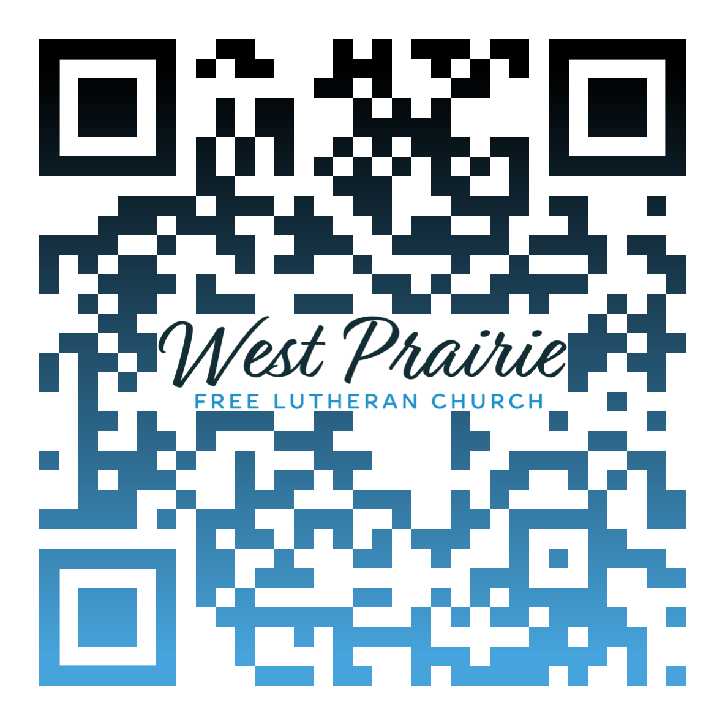
*Have any questions or needs, call Pastor Ryan at 701-429-7101

Monthly Missionary
This month our missionary highlight is a little unique. It's a church plant in the west metro area of the Twin Cities. Pastor Adam Osier is heading up that effort. The congregation will be called the Epiphany Free Lutheran Church. Prayer requests for this are 1) core planting team 2) prayer and financial partners and 3) wisdom and guidance for Pastor Osier and team

O Lord God of hosts, how long will you be angry with your people’s prayers?
Psalm 80:4

The writer of Psalm 80 brings a series of bold questions to the Lord, the Shepherd of Israel. How long will you be angry? Why have you allowed this? Why does it seem like the enemy is winning?
Scholars believe the psalmist is observing the downfall of the northern kingdom at the hands of Assyria. This has left the southern kingdom of Judah exposed to potential attack as well. The psalmist is brutally honest, asking why God would bring His chosen people out of Egypt only to be crushed by their enemies.
Current events in our country and around the world often have us asking similar questions. When we see such hurt and anger, it can seem like the power of the world and the schemes of the devil are winning out. We wonder why God would allow His church and our families to face such turmoil.
As I consider these uncertain times, I’m thankful for the ways God has grounded my faith to withstand the storms. He has given me a family who has pointed me to the truth. He has given me a call to pass along that truth to my children. He has given me two years at our Bible College and three years at our Seminary which instilled confidence that God’s Word is trustworthy and sufficient for all of life’s challenges. And He has given me a church family that reminds me I’m not alone on this journey.
From within this framework, I can reject human solutions, which ultimately lead to more pain and anger, and instead repeat the closing words of Psalm 80: “Restore us, O Lord God of hosts! Let your face shine, that we may be saved!” Although we don’t understand why God would allow evil or delay in answering our prayer, we recognize He is the only solution. In Jesus we find forgiveness, salvation, and victory.

Mr. Josh Johnson
FLBC Alumni, Class of 2011
Maranatha Free Lutheran Church
Glyndon, Minnesota

AFLC Promotion for September is the Bible College

HIDDEN TEXT

West Prairie Free Lutheran Church (AFLC)
Making the Gospel Known
15720 Highway 46 and 18 S. Kindred ND 58051
Pastor Ryan Patenaude 701-429-7101
https://westprairieaflc.com

