West Prairie Free Lutheran Church
Sunday School 9:15 a.m.
Worship Service 10:30 a.m.
Sixteenth Sunday after Trinity– September 20th, 2026

Prelude – Welcome – Announcements
Call to Worship Psalm 148:1-5
Praise the Lord! Praise the Lord from the heavens; praise him in the heights! Praise him, all his angels; praise him, all his hosts! Praise him, sun and moon, praise him, all you shining stars! Praise him, you highest heavens, and you waters above the heavens! Let them praise the name of the Lord! For he commanded and they were created.
Hymn Holy, Holy, Holy Hymn 134
Praises and Prayer Requests
Confession of Sin
Lord we confess with Isaiah: Woe is me! For I am lost; for I am a man of unclean lips, and I dwell in the midst of a people of unclean lips. Our hearts are calloused. Our consciences are dulled. Forgive us for our blindness, stubbornness and pride. We look to you as our only hope. Lord, have mercy.
Declaration of Grace
Worship Song Projected
Scripture Readings Isaiah 55:6-9 Pew Bible 615 Matthew 20:1-16 Pew Bible 825
Confession of Faith Apostles’ Creed Hymnal p 32
Offering
Hymn Immortal, Invisible, God Only Wise Hymn 184
Message Reputations 1 Samuel 29 Pew Bible 251
Hymn Turn Your Eyes Upon Jesus Hymn 526
The Lord’s Prayer
Benediction & Doxology Hymn 390

This week at West Prairie (September 20 – September 27)
Mon 6:00 p.m. JOY Committee Meeting
7:00 p.m. Women’s Bible Study
Wed 5:45 p.m. WOW
5:45 p.m. Confirmation
7:00 p.m. Youth Group
Sun 9:15 a.m. Sunday School
10:30 a.m. Worship Service

ANNOUNCEMENTS
Small Group: The Berges will be hosting at New Testament Bible Recap small group this fall starting on September 29th. It will be on Tuesdays at 6:00 p.m. You can sign up in the Narthex!

Fall Cleaning Week is scheduled for October 12-16!

REEL CHILI: Another chili cookoff and movie night is scheduled for October 3rd The cookoff will happen at 5:30 p.m. and then we will watch the “David” movie on the church lawn.

Night of Hope: There is a concert on Thursday, October 8th at the KPAC at Kindred High School. The bands are Consumed by Fire, V. Rose, and more! This is a FREE event, but you have to reserve your tickets. There is a flyer in the Narthex with a QR Code and more information!

Cuisine Crawl: Ladies, we are going to have a progressive dinner event on October 29th. We will be stopping at 5 homes for a 5-course meal. More information to come!

Reader next Sunday: Jared Ness
Ushers next Sunday: David and Debby Strand
Custodians for September: Jones & Paula Woodbury
Mower this week: Lucas Vangsness

How to give:
Offering
https://westprairieaflc.com/donate/

Planning Center App found at this QR Code:

Giving Update:
August Giving: $22,178.94
Monthly Budget: $14,208.33
Yearly Giving: $138,329.61
Yearly Budget: $113,666.64


Happy Birthday To:
22nd - Jack Woodbury
23rd - Amy Bakken
23rd - Evelyn Woodbury
26th - Everly Ness

Happy Anniversary To:
20th – Kent & Sarah Sannes

Cookbook:
We have a West Prairie church cookbook for sale! Payments of $25 can be made via cash or check designated to West Prairie Building Fund or on the Planning Center App indicated for the Building Fund. The extra books are in boxes in the Narthex.

Cookie Fellowship:
There is a sign-up for bringing cookies for fellowship time every Sunday in the Narthex!
September Monthly Bible Studies
Women: Sep. 21st at 7:00 p.m.
Women: Sep. 10th at 10:00 a.m.
Men: Sep. 15th at 7:00 p.m.

Youth Group
*Updates and announcements regarding youth group are sent via the band app. If you want to be in the loop check out this QR code:


Are you new here?
*Announcements, prayer requests, serving opportunities get sent out via email and text! We would love to get you in the loop. You can sign up by going to www.wpfl.flocknote.com or by scanning this QR Code:
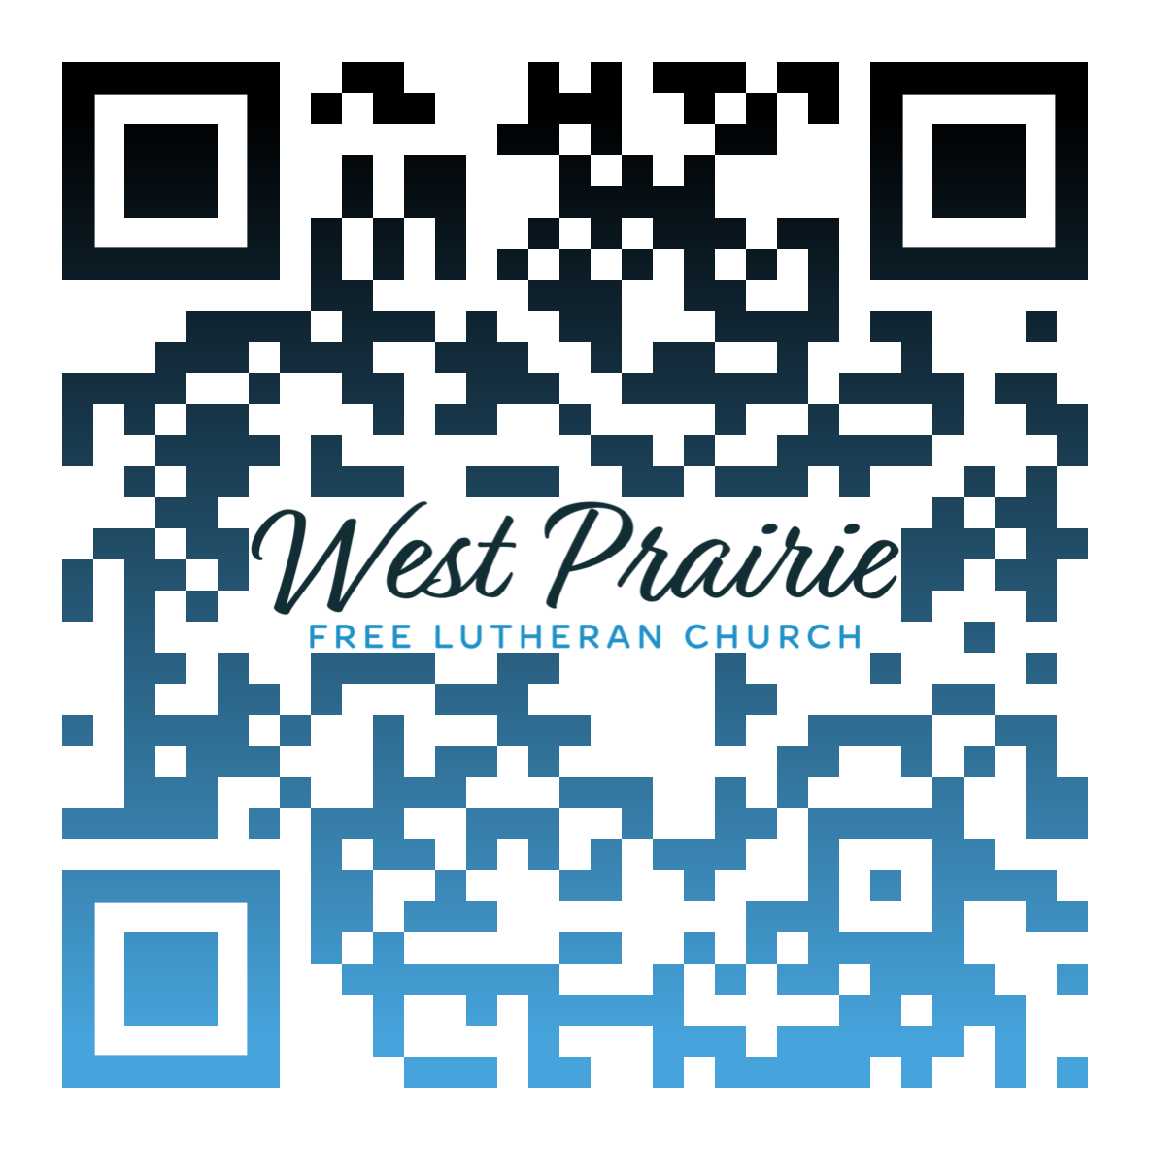
*Have any questions or needs, call Pastor Ryan at 701-429-7101

Monthly Missionary
This month our missionary highlight is a little unique. It's a church plant in the west metro area of the Twin Cities. Pastor Adam Osier is heading up that effort. The congregation will be called the Epiphany Free Lutheran Church. Prayer requests for this are 1) core planting team 2) prayer and financial partners and 3) wisdom and guidance for Pastor Osier and team

I’m so thankful that the LORD redirected my post high school plans. He changed my circumstances to change my heart. Instead of going right to college for sports, I landed at AFLBS. It was not a haphazard drop. God in His loving faithfulness knew just what I needed—
concentrated time in His Word and the fellowship of His people.
I came to the Bible School without clear direction for the future. The classes required concentrated time reading and memorizing the Bible. I learned to read the Word prayerfully. I learned to love its Author. My heart and prayers began to plead with God to direct my decisions. This pattern I learned at Bible School, seeking God through His Word and prayer, has shaped the turns of my life.
At AFLBS (now FLBC) God answered my earnest prayer, “What do You want me to study next?” Through time in Scripture and the impact of observing the day school in the basement of the girl’s dormitory (Medicine Lake Lutheran Academy), I was given a call. Teach.
After graduating from Oregon State University, I thought I would serve in public schools, and I did teach in Oregon, Idaho, California, and Minnesota. Yet most of my educational career was spent in the very Christian school God used to lead me into education in the first place: MLLA (now Heritage Christian Academy). God has been gracious in allowing me to serve Him in the field of education, wherever He placed me.
It has taken me too long to understand that any endeavor undertaken with an earnest desire to love God and love our neighbors is the highest vocation. Work, paid or unpaid, pleases God if it is done with this intent. Work itself is a gift from God; He does not need human accomplishments.
At AFLBS we memorized the great Shema: “Love the LORD your God with all your heart and with all your soul and with all your mind . . .” (Deuteronomy 6:4-9). Now, as I approach the end of my professional career, those verses continue to assure me that God will give me ways to serve Him in every chapter of life, if I seek Him. When what we do is motivated by love for God and love for others, our lives have eternal significance.

Mrs. Gwen Berge
FLBC (AFLBS) Alumni, Class of 1984
Anoka, Minnesota

AFLC Promotion for September is the Bible College

HIDDEN TEXT

West Prairie Free Lutheran Church (AFLC)
Making the Gospel Known
15720 Highway 46 and 18 S. Kindred ND 58051
Pastor Ryan Patenaude 701-429-7101
https://westprairieaflc.com

