West Prairie Free Lutheran Church
Sunday School 9:15 a.m.
Worship Service 10:30 a.m.
Seventeenth Sunday after Trinity– September 27th, 2026

Prelude – Welcome – Announcements
Call to Worship Psalm 148:7-10
Praise the Lord from the earth, you great sea creatures and all deeps, fire and hail, snow and mist, stormy wind fulfilling his word! Mountains and all hills, fruit trees and all cedars! Beasts and all livestock, creeping things and flying birds!
Hymn Praise to the Father, The Glorious King Hymn 140
Praises and Prayer Requests
Confession of Sin The Ten Commandments Hymnal p. 23
Declaration of Grace
Worship Song Projected
Scripture Readings Ezekiel 18:1-4, 25-32 Pew Bible 705 Matthew 21:23-27 Pew Bible 826
Confession of Faith Apostles’ Creed Hymnal p 32
Offering
Hymn Savior, Like a Shepherd Lead Us Hymn 450
Message Trials & Tribulations 1 Samuel 30 Pew Bible 251
Hymn What Can Wash Away My Sin Hymn 557
The Lord’s Prayer
Benediction & Doxology Hymn 390

This week at West Prairie (September 27 – October 4)
Tues 6:00 p.m. New Testament Small Group at Berge home
Wed 5:45 p.m. WOW
5:45 p.m. Confirmation
7:00 p.m. Youth Group
Sun 9:15 a.m. Sunday School
10:30 a.m. Worship Service

ANNOUNCEMENTS
Fall Cleaning Week is scheduled for October 12-16! It will be similar to the spring where there will be a checklist every day of items to be completed by anyone willing and able. Then a grand finale on Saturday to finish things up.

REEL CHILI: Another chili cookoff and movie night is scheduled for October 3rd The cookoff will happen at 5:30 p.m. and then we will watch the “David” movie on the church lawn. There is a sign-up in the Narthex for chilis! The more the better! It is going to be a yummy night!

Night of Hope: There is a concert on Thursday, October 8th at the KPAC at Kindred High School. The bands are Consumed by Fire, V. Rose, and more! This is a FREE event, but you have to reserve your tickets. There is a flyer in the Narthex with a QR Code and more information!

Cuisine Crawl: Ladies, we are going to have a progressive dinner event on October 29th. We will be stopping at 5 homes for a 5-course meal. We will be meeting at the Kindred Bus Barn at 5:30 p.m. and then going around to the 5 homes planning to end at 8:00 p.m. RSVP to Brenna (701-370-3306) so we can have a tally for food and make sure we have a spot on the bus for you!

Building Committee: Corey and his team at Valint Construction are now going through our architectural drawings and are “creating scopes of work”. We will work with them to finalize plans, get bids from contractors, and set up our project schedule beginning in Spring 2027.

Reader next Sunday: Michael Strand
Ushers next Sunday: Dennis & Tammy Jones
Custodians for September: Jones & Paula Woodbury
Mower this week: Michael Klockmann

How to give:
Offering
https://westprairieaflc.com/donate/

Planning Center App found at this QR Code:

Giving Update:
August Giving: $22,178.94
Monthly Budget: $14,208.33
Yearly Giving: $138,329.61
Yearly Budget: $113,666.64

Narthex resources to take home:
West Prairie Visitor Book
Lutheran Ambassador
West Prairie Directory
West Prairie Service Booklet

Happy Birthday To:
TODAY - Rebecca Woodbury

29th - Sarah Klockmann
2nd - Diane Myers
2nd - Landon Sannes

Happy Anniversary To:
1st – Tim & Marie Woodbury

Cookbook:
We have a West Prairie church cookbook for sale! Payments of $25 can be made via cash or check designated to West Prairie Building Fund or on the Planning Center App indicated for the Building Fund. The extra books are in boxes in the Narthex.
October Monthly Bible Studies
Women: Oct. 19th at 7:00 p.m.
Women: Oct. 8th at 10:00 a.m.
Men: Oct. 20th at 7:00 p.m.

Youth Group
*Updates and announcements regarding youth group are sent via the band app. If you want to be in the loop check out this QR code:


Are you new here?
*Announcements, prayer requests, serving opportunities get sent out via email and text! We would love to get you in the loop. You can sign up by going to www.wpfl.flocknote.com or by scanning this QR Code:
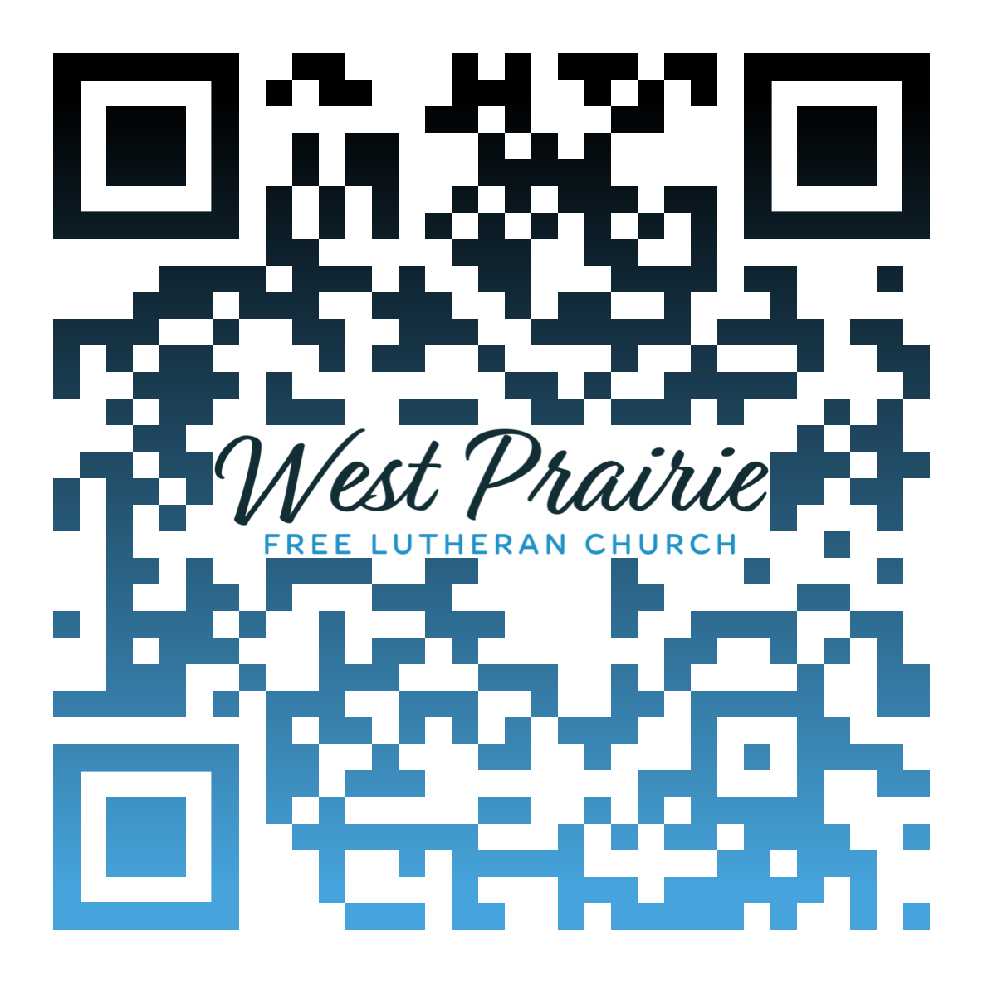
*Have any questions or needs, call Pastor Ryan at 701-429-7101

Monthly Missionary
This month our missionary highlight is a little unique. It's a church plant in the west metro area of the Twin Cities. Pastor Adam Osier is heading up that effort. The congregation will be called the Epiphany Free Lutheran Church. Prayer requests for this are 1) core planting team 2) prayer and financial partners and 3) wisdom and guidance for Pastor Osier and team

Working at Free Lutheran Bible College, I’m sometimes surprised by the very adult problems our students face: health problems, family conflicts, leadership struggles, loneliness, and sometimes even their own moral failing. By comparison, my early adult life was pretty easy. My biggest external problem as a student at FLBC was how little sleep I got, because I stayed up too long talking with friends the night before.
But problems are a fact of life. Some of them are our own fault; many of them are just fixtures of life in a broken world—a world that we broke.
When students tell me their stories, I’m often at a loss of what to say or how to help. Very occasionally I have a small piece of wisdom from my own experiences—from my own problems. When I am wisest, however, I remember that I am not the solution to their problems. They are already in the best place to get help—in community with other caring believers, looking at God’s Word together for the answers to life’s biggest questions.
That’s not to say our problems just go away because of some kind of magical happy feelings we get from reading Scripture. But the God that speaks to us through it deeply loves us. He knows our pain and hurt. He cares about our challenges. He offers peace and rest, even while the storm is raging. The job of the church (all believers) is to embody that love and care, be generous to each other with our time and resources, and point each other to the ultimate caregiver.
So, no matter what your problems are right now, remember where peace comes. Like our students, lean into community with other caring believers, looking at God’s Word together for the answers to life’s biggest questions.
“Peace I leave with you; my peace I give you. I do not give to you as the world gives. Do not let your hearts be troubled and do not be afraid” (John 14:27).

Mr. Luke Quanbeck
FLBC Alumni, Class of 2012
Plymouth, Minnesota

AFLC Promotion for September is the Bible College

HIDDEN TEXT

West Prairie Free Lutheran Church (AFLC)
Making the Gospel Known
15720 Highway 46 and 18 S. Kindred ND 58051
Pastor Ryan Patenaude 701-429-7101
https://westprairieaflc.com

