West Prairie Free Lutheran Church
Worship Service 9:30 a.m.
Fourteenth Sunday after Trinity– September 6th, 2026

Prelude – Welcome – Announcements
Call to Worship Psalm 95:6-7a
Oh come, let us worship and bow down; let us kneel before the Lord, our Maker! For he is our God, and we are the people of his pasture, and the sheep of his hand.
Hymn Praise to the Father, The Glorious King Hymn 140
Praises and Prayer Requests
Confession of Sin Silent Prayer
Declaration of Grace
Worship Song Projected
Scripture Readings Ezekiel 33:7-9 Pew Bible 721 Matthew 18:1-20 Pew Bible 823
Confession of Faith Nicene Creed Hymnal p 32
Offering
Hymn Savior, Like a Shepherd Lead Us Hymn 450
Message Peace at a Cost 1 Samuel 27 Pew Bible 249
Hymn What Can Wash Away My Sin Hymn 557
Celebration of the Lord’s Supper
The Lord’s Prayer
Benediction & Doxology Hymn 390

This week at West Prairie (September 6 – September 13)
Tues 7:00 p.m. Council Meeting
Wed 5:45 p.m. WOW
5:45 p.m. Confirmation
7:00 p.m. Youth Group
Thurs. 10:00 a.m. Women’s Bible Study
Sat 12:00 p.m. Matt Andvik Celebration of life at Kindred Lutheran
Sun 9:15 a.m. Sunday School (Scavenger hunt and donuts!!)
10:30 a.m. Worship Service

ANNOUNCEMENTS
Small Groups this Fall: It looks like we might just have the one option for small groups this fall with the Berge’s New Testament Bible Recap one on Tuesdays at 6:00 p.m. starting September 29th. If you are interested- you can sign-up in the Narthex. If you are interested in providing another option- talk to Pastor Ryan!

New Member Class: Interested in becoming a member at West Prairie? Pastor Ryan will be teaching a new membership class September 20-October 11 at 9:15 on Sunday mornings. Let him know if you are interested in attending!

WMF Fall Rally: The district WMF Fall Rally is being held at Ebenezer Free Lutheran Church in Northwood on September 19th starting at 9:30 a.m. Registration is $15 which includes a luncheon. There will be speakers and devotionals and lots of good fellowship!

Cookie Fellowship: We are going to be back to having cookie fellowship on Sunday mornings on September 20th! If you are interested in signing up to bring cookies- check out the sign-up in the Narthex!

REEL CHILI: Another chili cookoff and movie night is scheduled for October 3rd The cookoff will happen at 5:30 p.m. and then we will watch the “David” movie on the church lawn.

Cuisine Crawl: Ladies, we are going to have a progressive dinner event on October 29th. We will be stopping at 5 homes for a 5-course meal! More information to come!

Reader next Sunday: Caleb Holt
Ushers next Sunday: Michael and Sarah Klockmann
Custodians for September: Jones & Paula Woodbury
Mower this week: Mark Larsen

How to give:
Offering
https://westprairieaflc.com/donate/

Planning Center App found at this QR Code:

Giving Update:
June Giving: $14,068.03
Monthly Budget: $14,208.33
Yearly Giving: $94,323.04
Yearly Budget: $85,249.98

Narthex resources to take home:
West Prairie Visitor Book
Lutheran Ambassador
West Prairie Directory
West Prairie Service Booklet


Happy Birthday To:
8th - Violette Richardson
9th - Sawyer Richardson
10th - Ray Martinson
10th - Karson Murphy
11th - Piper Kommer
11th - Bryce Woodbury
12th - Jamie Bakken

Happy Anniversary To:
8th – Wade & Bobbi Woodbury

Cookbook:
We have a West Prairie church cookbook for sale! Payments of $25 can be made via cash or check designated to West Prairie Building Fund or on the Planning Center App indicated for the Building Fund. The extra books are in boxes in the Narthex.

September Monthly Bible Studies
Women: Sep. 21st at 7:00 p.m.
Women: Sep. 10th at 10:00 a.m.
Men: Sep. 15th at 7:00 p.m.

Youth Group
*Updates and announcements regarding youth group are sent via the band app. If you want to be in the loop check out this QR code:


Are you new here?
*Announcements, prayer requests, serving opportunities get sent out via email and text! We would love to get you in the loop. You can sign up by going to www.wpfl.flocknote.com or by scanning this QR Code:
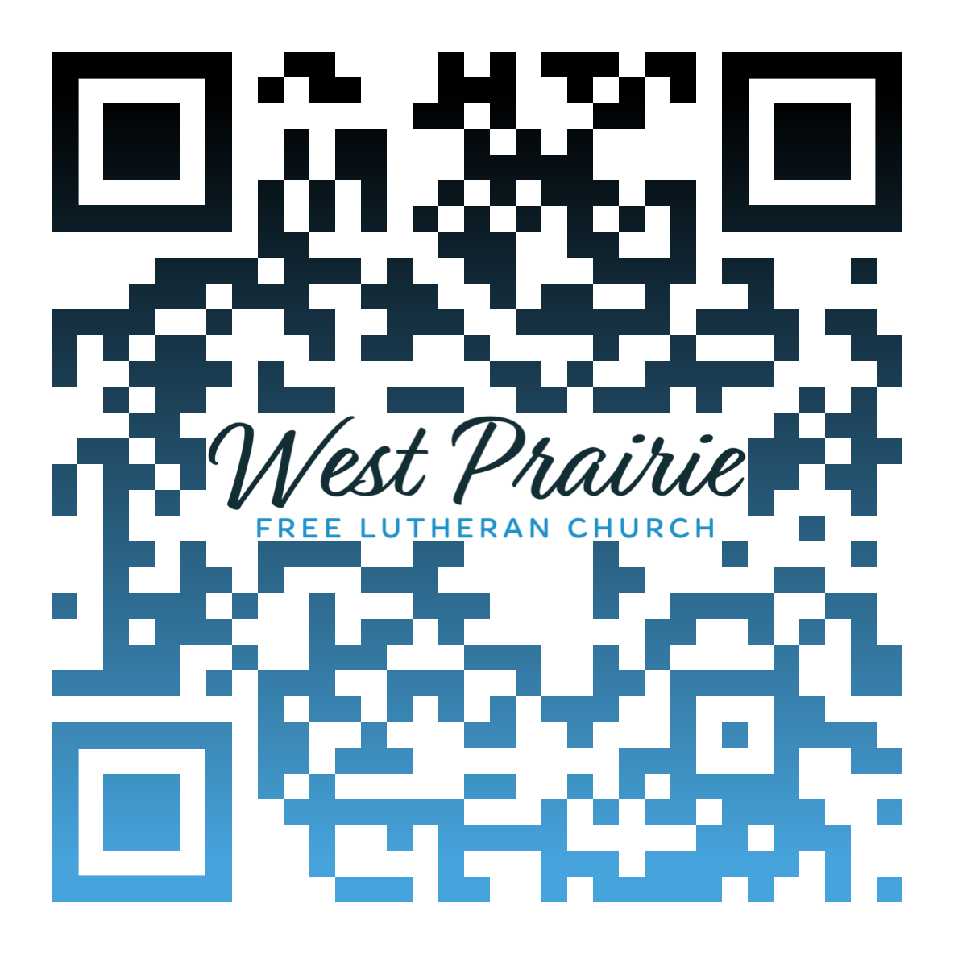
*Have any questions or needs, call Pastor Ryan at 701-429-7101

I think about the butterfly effect often, the idea that if one little choice I made was different—if I had sent my college application to a different school, if I had played hooky at the FLBC Missions Spotlight week, if I hadn’t embraced mentorship and leadership from my professors who all encouraged me to pursue missions—that I wouldn’t have been walking the streets of Lviv, Ukraine, this morning.
The Lord is the best composer, and He specializes in orchestrating our lives. What started with membership at Westaker Free Lutheran because of my parents led to applying and attending FLBC, which led to working with the World Mission Prayer League because of the Missions Spotlight week, which led me here to Lviv, Ukraine, where, coincidently, I work and serve alongside Tomasz and Miriam Chmiel, fellow alumni twenty-two years my senior.
In thinking back to my time at FLBC, I clearly see the path God paved to lead me directly here to Ukraine. Not only through the “butterfly effect” orchestrating, but through the very tangible mentorship and education I received. I can think of many biblical and faith-based questions I’ve been asked here that I wouldn’t have answers to without the generals in theology and biblical history I took. I think of behaviors and lessons I wouldn’t have learned without my electives in youth ministry and missions, and even my worship leading extracurricular. There are also conversations I’m having with girls I’m discipling that mirror exact conversations I was having and questions I was asking my professors just two years ago. Because of their patience and openness to my doubts and struggles, I am now able to lead my girls through what I was led through. Even on a personal level, I can reflect and lean on the training and education I received and further study and encounter the Lord.
Through FLBC, I was given countless opportunities, connected with countless leaders, mentors, and friends, and took countless steps in my relationship with the Lord and in my walk towards biblical knowledge, maturity, and service. While I trust that the Lord would have guided my steps for His glory regardless, I am deeply thankful He led me this way, bringing me exactly down this path and exactly to this place!

Miss Ellen Dalager
FLBC Alumni, Class of 2024
Minneapolis, Minnesota

AFLC Promotion for September is the Bible College

HIDDEN TEXT

West Prairie Free Lutheran Church (AFLC)
Making the Gospel Known
15720 Highway 46 and 18 S. Kindred ND 58051
Pastor Ryan Patenaude 701-429-7101
https://westprairieaflc.com

